HAPTER

UNIT –I

Unit Objectives:

- To learn about the history and various root technologies of Cloud computing.
- To learn about various vital components of different computing models.

Introduction

Computing is being transformed into a model consisting of services that are commoditized and delivered in a manner similar to utilities such as water, electricity, gas, and telephony. In such a model, users access services based on their requirements, regardless of where the services are hosted. Several computing paradigms, such as grid computing, have promised to deliver this utility computing vision. Cloud computing is the most recent emerging paradigm promising to turn the vision of “computing utilities” into a reality.

Cloud computing is a technological advancement that focuses on the way we design computing systems, develop applications, and leverage existing services for building software. It is based on the concept of dynamic provisioning, which is applied not only to services but also to compute capability, storage, networking, and information technology (IT) infrastructure in general. Resources are made available through the Internet and offered on a pay-per-use basis from cloud computing vendors. Today, anyone with a credit card can subscribe to cloud services and deploy and configure servers for an application in hours, growing and shrinking the infrastructure serving its application according to the demand, and paying only for the time these resources have been used.

This chapter provides a brief overview of the cloud computing phenomenon by presenting its vision, discussing its core features, and tracking the technological developments that have made it possible. The chapter also introduces some key cloud computing technologies as well as some insights into development of cloud computing environments.

Cloud computing at a glance

In 1969, Leonard Kleinrock, one of the chief scientists of the original Advanced Research Projects Agency Network (ARPANET), which seeded the Internet, said:
As of now, computer networks are still in their infancy, but as they grow up and become sophisticated, we will probably see the spread of ‘computer utilities’ which, like present electric and tele-phone utilities, will service individual homes and offices across the country.
This vision of computing utilities based on a service-provisioning model anticipated the massive transformation of the entire computing industry in the 21st century, whereby computing services will be readily available on demand, just as other utility services such as water, electricity, tele-phone, and gas are available in today’s society. Similarly, users (consumers) need to pay providers

only when they access the computing services. In addition, consumers no longer need to invest heavily or encounter difficulties in building and maintaining complex IT infrastructure.

In such a model, users access services based on their requirements without regard to where the services are hosted. This model has been referred to as utility computing or, recently (since 2007), as cloud computing. The latter term often denotes the infrastructure as a “cloud” from which busi-nesses and users can access applications as services from anywhere in the world and on demand. Hence, cloud computing can be classified as a new paradigm for the dynamic provisioning of com-puting services supported by state-of-the-art data centers employing virtualization technologies for consolidation and effective utilization of resources.

Cloud computing allows renting infrastructure, runtime environments, and services on a pay-per-use basis. This principle finds several practical applications and then gives different images of cloud computing to different people. Chief information and technology officers of large enterprises see opportunities for scaling their infrastructure on demand and sizing it according to their business needs. End users leveraging cloud computing services can access their documents and data anytime, anywhere, and from any device connected to the Internet. Many other points of view exist. One of the most diffuse views of cloud computing can be summarized as follows:
I don’t care where my servers are, who manages them, where my documents are stored, or where my applications are hosted. I just want them always available and access them from any device connected through Internet. And I am willing to pay for this service for as a long as I need it.
The concept expressed above has strong similarities to the way we use other services, such as water and electricity. In other words, cloud computing turns IT services into utilities. Such a deliv-ery model is made possible by the effective composition of several technologies, which have reached the appropriate maturity level. Web 2.0 technologies play a central role in making cloud computing an

attractive opportunity for building computing systems. They have transformed the Internet into a rich application and service delivery platform, mature enough to serve complex needs. Service orientation allows cloud computing to deliver its capabilities with familiar abstractions, while virtualization confers on cloud computing the necessary degree of customization, control, and flexibility for building production and enterprise systems.

Besides being an extremely flexible environment for building new systems and applications, cloud computing also provides an opportunity for integrating additional capacity or new features into existing systems. The use of dynamically provisioned IT resources constitutes a more attractive opportunity than buying additional infrastructure and software, the sizing of which can be difficult to estimate and the needs of which are limited in time. This is one of the most important advantages of cloud computing, which has made it a popular phenomenon. With the wide deployment of cloud computing systems, the foundation technologies and systems enabling them are becoming consolidated and standardized. This is a fundamental step in the realization of the long-term vision for cloud computing, which provides an open environment where computing, storage, and other ser-vices are traded as computing utilities.

The vision of cloud computing

Cloud computing allows anyone with a credit card to provision virtual hardware, runtime environments, and services. These are used for as long as needed, with no up-front commitments required. The entire stack of a computing system is transformed into a collection of utilities, which can be provisioned and composed together to deploy systems in hours rather than days and with virtually no

maintenance costs. This opportunity, initially met with skepticism, has now become a practice across several application domains and business sectors (see Figure 1.1). The demand has fast-tracked technical development and enriched the set of services offered, which have also become more sophisticated and cheaper.

Despite its evolution, the use of cloud computing is often limited to a single service at a time or, more commonly, a set of related services offered by the same vendor. Previously, the lack of effective standardization efforts made it difficult to move hosted services from one vendor to another. The long-term vision of cloud computing is that IT services are traded as utilities in an open market, without technological and legal barriers. In this cloud marketplace, cloud service providers and consumers, trading cloud services as utilities, play a central role.

Many of the technological elements contributing to this vision already exist. Different stake-holders leverage clouds for a variety of services. The need for ubiquitous storage and compute power on demand is the most common reason to consider cloud computing. A scalable runtime for applications is an attractive option for application and system developers that do not have infra-structure or cannot afford any further expansion of existing infrastructure. The capability for Web-based access to documents and their processing using sophisticated applications is one of the appealing factors for end users.

In all these cases, the discovery of such services is mostly done by human intervention: a person (or a team of people) looks over the Internet to identify offerings that meet his or her needs. We imagine that in the near future it will be possible to find the solution that matches our needs by simply entering our request in a global digital market that trades cloud computing services. The existence of such a market will enable the automation of the discovery process and its integration into existing software systems, thus allowing users to transparently leverage cloud resources in their applications and systems. The existence of a global platform for trading cloud services will also help service providers become more visible and therefore potentially increase their revenue. A global cloud market also reduces the barriers between service consumers and providers: it is no longer necessary to belong to only one of these two categories. For example, a cloud provider might become a consumer of a competitor service in order to fulfill its own promises to customers.

These are all possibilities that are introduced with the establishment of a global cloud computing marketplace and by defining effective standards for the unified representation of cloud services as well as the interaction among different cloud technologies. A considerable shift toward cloud computing has already been registered, and its rapid adoption facilitates its consolidation. Moreover, by concentrating the core capabilities of cloud computing into large datacenters, it is possible to reduce or remove the need for any technical infrastructure on the service consumer side. This approach provides opportunities for optimizing datacenter facilities and fully utilizing their

I need to grow my

infrastructure, but

I do not know for

how long…

I cannot invest in

infrastructure, I

just started my

business….

I want to focus on

application logic and

not maintenance and

scalability issues

I want to access and

edit my documents

and photos from

everywhere..

FIGURE 1.1

Cloud computing vision.
I have a lot of
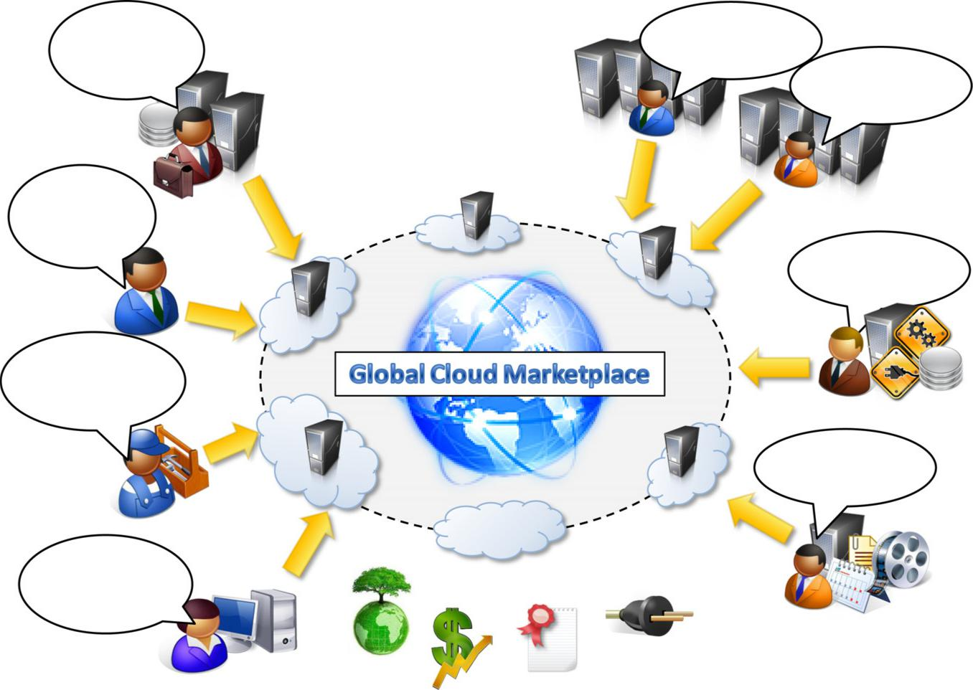
infrastructure that I
want to rent …
I have a surplus of

infrastructure that I

want to make use of

I have infrastructure

and middleware and I

can host applications

I have infrastructure

and provide

application services

capabilities to serve multiple users. This consolidation model will reduce the waste of energy and carbon emissions, thus contributing to a greener IT on one end and increasing revenue on the other end.

Defining a cloud

Cloud computing has become a popular buzzword; it has been widely used to refer to different technologies, services, and concepts. It is often associated with virtualized infrastructure or hard-ware on demand, utility computing, IT outsourcing, platform and software as a service, and many other things that now are the focus of the IT industry. Figure 1.2 depicts the plethora of different notions included in current definitions of cloud computing.

The term cloud has historically been used in the telecommunications industry as an abstraction of the network in system diagrams. It then became the symbol of the most popular computer network: the Internet. This meaning also applies to cloud computing, which refers to an Internet-centric way of

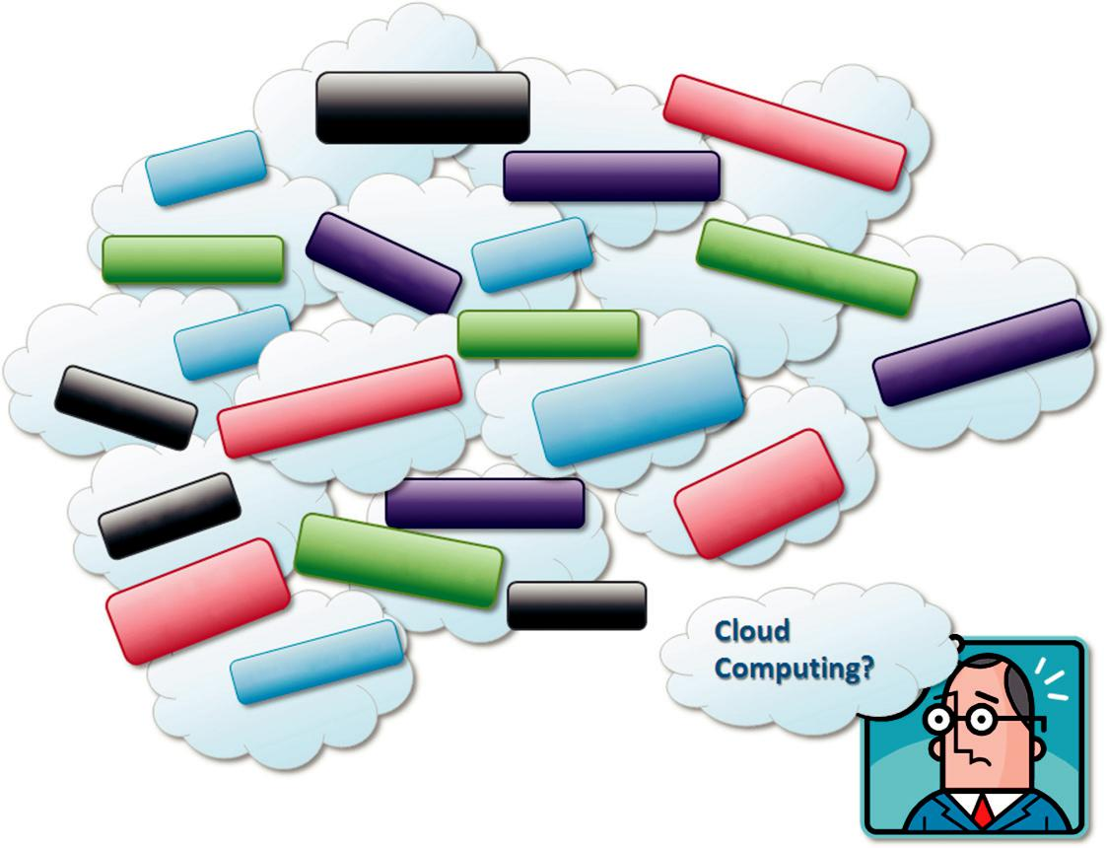

SaaS

No capital

investments

Cloudbusrting

Quality of Service

Pay as you go |  | Internet
IaaS
Elasticity | IT | outsourcing

PaaS

Billing

Level
Service

Agreement

Green | computing

computing

Utility

Scalability |  | IT outsourcing
 |  | Privacy &
Provisioning |  | Trust
 |  | Security
 | demand | Security
on
 |  | Virtualization

DatacentersVirtual

FIGURE 1.2

Cloud computing technologies, concepts, and ideas

computing. The Internet plays a fundamental role in cloud computing, since it represents either the medium or the platform through which many cloud computing services are delivered and made accessible. This aspect is also reflected in the definition given by Armbrust et al.
Cloud computing refers to both the applications delivered as services over the Internet and the hardware and system software in the datacenters that provide those services.

This definition describes cloud computing as a phenomenon touching on the entire stack: from the underlying hardware to the high-level software services and applications. It introduces the concept of everything as a service, mostly referred as XaaS,² where the different components of a system—IT infrastructure, development platforms, databases, and so on—can be delivered, measured, and consequently priced as a service. This new approach significantly influences not only the way that we build software but also the way we deploy it, make it accessible, and design our IT infra-structure, and even the way companies allocate the costs for IT needs. The approach fostered by cloud computing is global: it covers both the needs of a single user hosting documents in the cloud and the ones of a CIO deciding to deploy part of or the entire corporate IT infrastructure in the pub-lic cloud. This notion of multiple parties using a shared cloud computing environment is highlighted in a definition proposed by the U.S. National Institute of Standards and Technology (NIST):

Cloud computing is a model for enabling ubiquitous, convenient, on-demand network access to a shared pool of configurable computing resources (e.g., networks, servers, storage, applications, and services) that can be rapidly provisioned and released with minimal management effort or service provider interaction.

Another important aspect of cloud computing is its utility-oriented approach. More than any other trend in distributed computing, cloud computing focuses on delivering services with a given pricing model, in most cases a “pay-per-use” strategy. It makes it possible to access online storage, rent virtual hardware, or use development platforms and pay only for their effective usage, with no or minimal up-front costs. All these operations can be performed and billed simply by entering the credit card details and accessing the exposed services through a Web browser. This helps us pro-vide a different and more practical characterization of cloud computing. According to Rees, we can define three criteria to discriminate whether a service is delivered in the cloud computing style:

The service is accessible via a Web browser (nonproprietary) or a Web services application programming interface (API).

Zero capital expenditure is necessary to get started. You pay only for what you use as you use it.

Even though many cloud computing services are freely available for single users, enterprise-class services are delivered according a specific pricing scheme. In this case users subscribe to the service and establish with the service provider a service-level agreement (SLA) defining the quality-of-service parameters under which the service is delivered. The utility-oriented nature of cloud computing is clearly expressed by Buyya et al.:

A cloud is a type of parallel and distributed system consisting of a collection of interconnected and virtualized computers that are dynamically provisioned and presented as one or more unified computing resources based on service-level agreements established through negotiation between the service provider and consumers.

A closer look

Cloud computing is helping enterprises, governments, public and private institutions, and research organizations shape more effective and demand-driven computing systems. Access to, as well as integration of, cloud computing resources

and systems is now as easy as performing a credit card transaction over the Internet. Practical examples of such systems exist across all market segments:
Large enterprises can offload some of their activities to cloud-based systems. Recently, the New York Times has converted its digital library of past editions into a Web-friendly format. This required a considerable amount of computing power for a short period of time. By renting Amazon EC2 and S3 Cloud resources, the Times performed this task in 36 hours and relinquished these resources, with no additional costs.

Small enterprises and start-ups can afford to translate their ideas into business results more quickly, without excessive up-front costs. Animoto is a company that creates videos out of images, music, and video fragments submitted by users. The process involves a considerable amount of storage and backend processing required for producing the video, which is finally made available to the user. Animoto does not own a single server and bases its computing infrastructure entirely on Amazon Web Services, which are sized on demand according to

the overall workload to be processed. Such workload can vary a lot and require instant scalability. Up-front investment is clearly not an effective solution for many companies, and cloud computing systems become an appropriate alternative.

- System developers can concentrate on the business logic rather than dealing with the complexity of infrastructure management and scalability. Little Fluffy Toys is a company in London that has developed a widget providing users with information about nearby bicycle rental services. The company has managed to back the widget’s computing needs on Google AppEngine and be on the market in only one week.

- End users can have their documents accessible from everywhere and any device. Apple iCloud is a service that allows users to have their documents stored in the Cloud and access them from any device users connect to it. This makes it possible to take a picture while traveling with a smartphone, go back home and edit the same picture on your laptop, and have it show as updated on your tablet computer. This process is completely transparent to the user, who does not have to set up cables and connect these devices with each other.

- How is all of this made possible? The same concept of IT services on demand—whether com-puting power, storage, or runtime environments for applications—on a pay-as-you-go basis accommodates these four different scenarios. Cloud computing does not only contribute with the opportunity of easily accessing IT services on demand, it also introduces a new way of thinking about IT services and resources: as utilities. A bird’s-eye view of a cloud computing environment is shown in Figure 1.3.

- The three major models for deploying and accessing cloud computing environments are public clouds, private/enterprise clouds, and hybrid clouds (see Figure 1.4). Public clouds are the most common deployment models in which necessary IT infrastructure (e.g., virtualized datacenters) is established by a third-party service provider that makes it available to any consumer on a subscription basis. Such clouds are appealing to users because they allow users to quickly leverage com-pute, storage, and application services. In this environment, users’ data and applications are deployed on cloud datacenters on the vendor’s premises.

Large organizations that own massive computing infrastructures can still benefit from cloud computing by replicating the cloud IT service delivery model in-house. This idea has given birth to the concept of private clouds as opposed to public clouds. In 2010, for example, the U.S. federal government, one of the world’s largest consumers of IT spending (around $76 billion on more than

Manjrasoft

Subscription - Oriented Cloud Services:
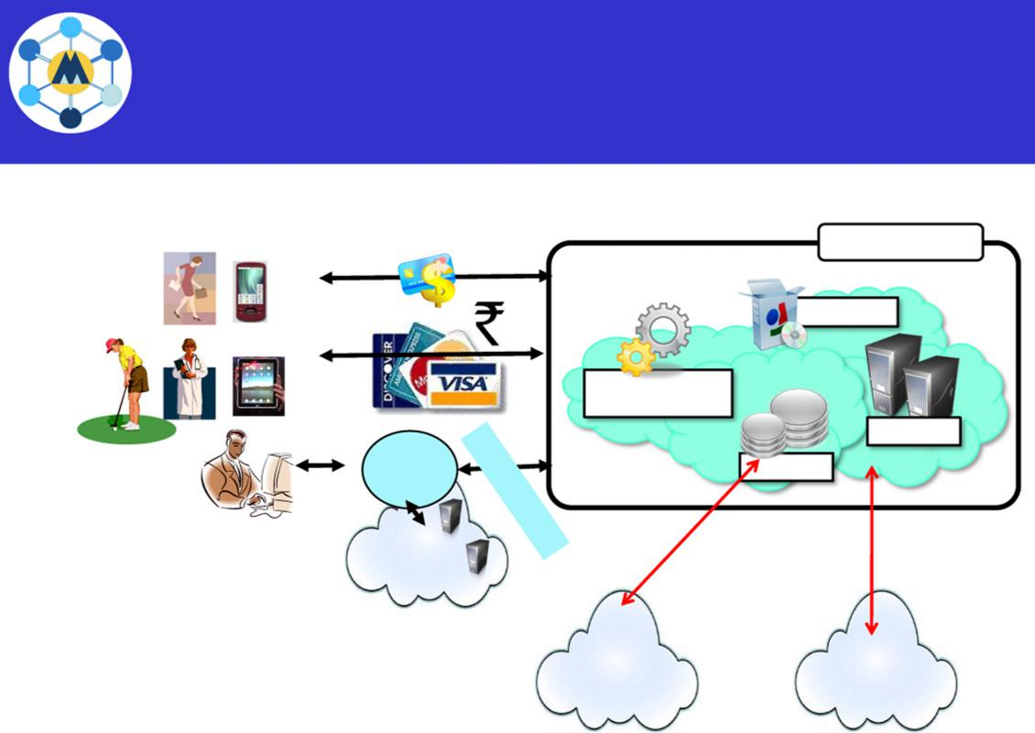

X{compute, apps, data, ..}

as a Service (..aaS)

Public Clouds

 | Applications
 | Development and
 | Runtime Platform
 | Compute
Cloud | Storage
Manager | Storage

Clients Private

Cloud

Other

Cloud Services

Govt.

Cloud Services

FIGURE 1.3

A bird’s-eye view of cloud computing.

Cloud Deployment Models
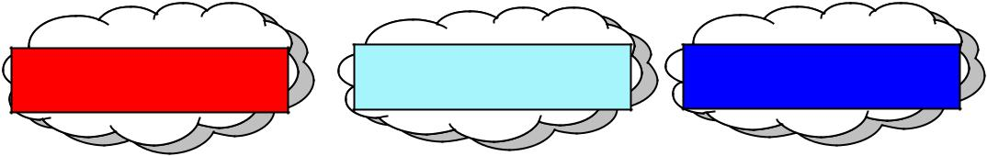

Public/Internet | Private/Enterprise | Hybrid/Inter
Clouds | Clouds | Clouds
*Third-party, | *A public cloud model | * Mixed use of
multitenant cloud | *A public cloud model | * Mixed use of
multitenant cloud | within a | private and public
infrastructure | within a | private and public
infrastructure | company’s own | clouds; leasing public
and services | company’s own | clouds; leasing public
and services | datacenter/infrastructure | cloud services
*Available on a | for internal | when private cloud
*Available on a | and/or partners’ use | capacity is insufficient
subscription basis to all | and/or partners’ use | capacity is insufficient
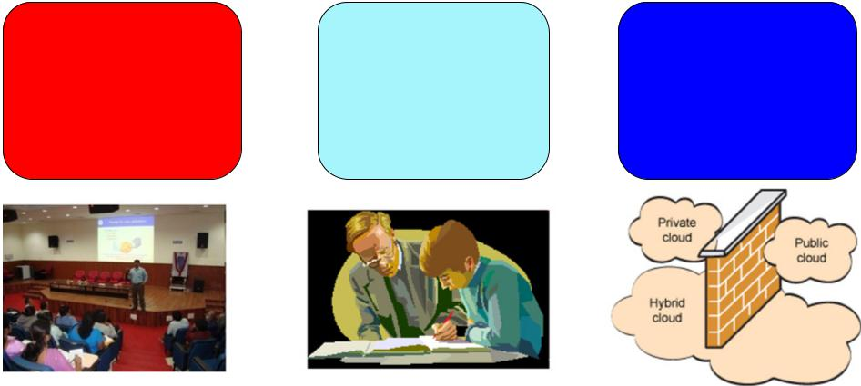

FIGURE 1.4

Major deployment models for cloud computing.

10,000 systems) started a cloud computing initiative aimed at providing government agencies with a more efficient use of their computing facilities. The use of cloud-based in-house solutions is also driven by the need to keep confidential information within an organization’s premises. Institutions such as governments and banks that have high security, privacy, and regulatory concerns prefer to build and use their own private or enterprise clouds.

Whenever private cloud resources are unable to meet users’ quality-of-service requirements, hybrid computing systems, partially composed of public cloud resources and privately owned infra-structures, are created to serve the organization’s needs. These are often referred as hybrid clouds, which are becoming

a common way for many stakeholders to start exploring the possibilities offered by cloud computing.

The cloud computing reference model

A fundamental characteristic of cloud computing is the capability to deliver, on demand, a variety of IT services that are quite diverse from each other. This variety creates different perceptions of what cloud computing is among users. Despite this lack of uniformity, it is possible to classify cloud computing services offerings into three major categories: Infrastructure-as-a-Service (IaaS), Platform-as-a-Service (PaaS), and Software-as-a-Service (SaaS). These categories are related to each other as described in Figure 1.5, which provides an organic view of cloud computing. We refer to this diagram as the Cloud Computing Reference Model, and we will use it throughout the
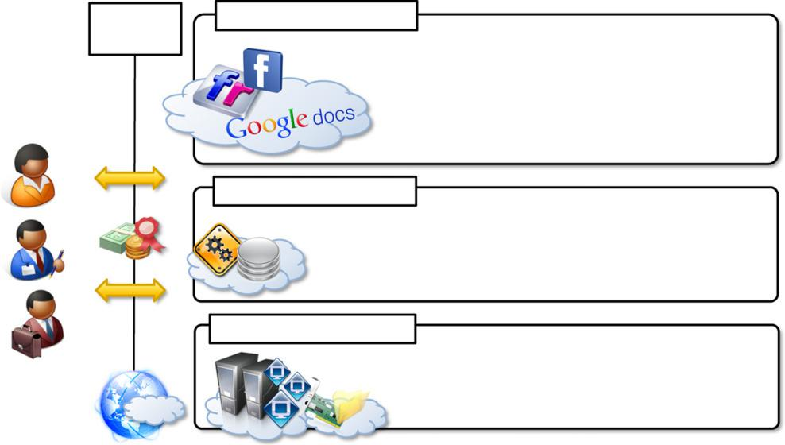

Web 2.0 | Software as a Service
Interfaces | End-user applications
 | Scientific applications
 | Office automation, photo editing,
 | CRM, and social networking
 | Examples : Google Documents, Facebook, Flickr, Salesforce
 | Platform as a Service
 | Runtime environment for applications
 | Development and data processing platforms
 | Examples : Windows Azure, Hadoop, Google AppEngine, Aneka
 | Infrastructure as a Service
 | Virtualized servers
 | Storage and networking
 | Examples : Amazon EC2, S3, Rightscale, vCloud

FIGURE 1.5

The Cloud Computing Reference Model.

book to explain the technologies and introduce the relevant research on this phenomenon. The model organizes the wide range of cloud computing services into a layered view that walks the computing stack from bottom to top.

At the base of the stack, Infrastructure-as-a-Service solutions deliver infrastructure on demand in the form of virtual hardware, storage, and networking. Virtual hardware is utilized to provide compute on demand in the form of virtual machine instances. These are created at users’ request on the provider’s infrastructure, and users are given tools and interfaces to configure the software stack installed in the virtual machine. The pricing model is usually defined in terms of dollars per hour, where the hourly cost is influenced by the characteristics of the virtual hardware. Virtual storage is delivered in the form of raw disk space or object store. The former complements a virtual hardware offering that requires persistent storage. The latter is a more high-level abstraction for storing entities rather than

files. Virtual networking identifies the collection of services that manage the networking among virtual instances and their connectivity to the Internet or private networks.

Platform-as-a-Service solutions are the next step in the stack. They deliver scalable and elastic runtime environments on demand and host the execution of applications. These services are backed by a core middleware platform that is responsible for creating the abstract environment where applications are deployed and executed. It is the responsibility of the service provider to provide scalability and to manage fault tolerance, while users are requested to focus on the logic of the application developed by leveraging the provider’s APIs and libraries. This approach increases the level of abstraction at which cloud computing is leveraged but also constrains the user in a more controlled environment.

At the top of the stack, Software-as-a-Service solutions provide applications and services on demand. Most of the common functionalities of desktop applications—such as office automation, document management, photo editing, and customer relationship management (CRM) software—are replicated on the provider’s infrastructure and made more scalable and accessible through a browser on demand. These applications are shared across multiple users whose interac-tion is isolated from the other users. The SaaS layer is also the area of social networking Websites, which leverage cloud-based infrastructures to sustain the load generated by their popularity.

Each layer provides a different service to users. IaaS solutions are sought by users who want to leverage cloud computing from building dynamically scalable computing systems requiring a specific software stack. IaaS services are therefore

used to develop scalable Websites or for back-ground processing. PaaS solutions provide scalable programming platforms for developing applications and are more appropriate when new systems have to be developed. SaaS solutions tar-get mostly end users who want to benefit from the elastic scalability of the cloud without doing any software development, installation, configuration, and maintenance. This solution is appropriate when there are existing SaaS services that fit users needs (such as email, document management, CRM, etc.) and a minimum level of customization is needed.

Characteristics and benefits

Cloud computing has some interesting characteristics that bring benefits to both cloud service consumers (CSCs) and cloud service providers (CSPs). These characteristics are:

- No up-front commitments
- On-demand access
- Nice pricing
- Simplified application acceleration and scalability
- Efficient resource allocation
- Energy efficiency
- Seamless creation and use of third-party services

The most evident benefit from the use of cloud computing systems and technologies is the increased economical return due to the reduced maintenance costs and operational costs related to IT software and infrastructure. This is mainly because IT assets, namely software and infrastructure, are turned into utility costs, which are paid for as long as they are used, not paid for up front. Capital costs are costs

associated with assets that need to be paid in advance to start a business activity. Before cloud computing, IT infrastructure and software generated capital costs, since they were paid up front so that business start-ups could afford a computing infrastructure, enabling the business activities of the organization. The revenue of the business is then utilized to compensate over time for these costs. Organizations always minimize capital costs, since they are often associated with depreciable values. This is the case of hardware: a server bought today for $1,000 will have a market value less than its original price when it is eventually replaced by new hardware. To make profit, organizations have to compensate for this depreciation created by time, thus reducing the net gain obtained from revenue. Minimizing capital costs, then, is fundamental. Cloud computing transforms IT infrastructure and software into utilities, thus significantly contributing to increasing a company’s net gain. Moreover, cloud computing also provides an opportunity for small organizations and start-ups: these do not need large investments to start their business, but they can comfortably grow with it. Finally, maintenance costs are significantly reduced: by renting the

infrastructure and the application services, organizations are no longer responsible for their maintenance. This task is the responsibility of the cloud service provider, who, thanks to economies of scale, can bear the maintenance costs.

Increased agility in defining and structuring software systems is another significant benefit of cloud computing. Since organizations rent IT services, they can more dynamically and flexibly com-pose their software systems, without being constrained by capital costs for IT assets. There is a reduced need for capacity planning, since cloud computing allows organizations to react to unplanned surges in demand quite rapidly. For example, organizations can add more servers to pro-cess workload spikes and dismiss them when they are no longer needed. Ease of scalability is another advantage. By leveraging the potentially huge capacity of cloud computing, organizations can extend their IT capability more easily. Scalability can be leveraged across the entire computing stack. Infrastructure providers offer simple methods to provision customized hardware and integrate it into existing systems. Platform-as-a-Service providers offer runtime environment and programming mod-els that are designed to scale applications. Software-as-a-Service offerings can be elastically sized on demand without requiring users to provision hardware or to program application for scalability.

End users can benefit from cloud computing by having their data and the capability of operating on it always available, from anywhere, at any time, and through multiple devices. Information and services stored in the cloud are exposed to users by Web-based interfaces that make them accessi-ble from portable devices as well as desktops at home. Since the processing capabilities (that is, office automation features, photo editing, information management, and so on) also reside

in the cloud, end users can perform the same tasks that previously were carried out through considerable software investments. The cost for such opportunities is generally very limited, since the cloud ser-vice provider shares its costs across all the tenants that he is servicing. Multitenancy allows for bet-ter utilization of the shared infrastructure that is kept operational and fully active. The concentration of IT infrastructure and services into large datacenters also provides opportunity for considerable optimization in terms of resource allocation and energy efficiency, which eventually can lead to a less impacting approach on the environment.

Finally, service orientation and on-demand access create new opportunities for composing sys-tems and applications with a flexibility not possible before cloud computing. New service offerings can be created by aggregating together existing services and concentrating on added value. Since it is possible to provision on demand any component of the computing stack, it is easier to turn ideas into products with limited costs and by concentrating technical efforts on what matters: the added value.

Challenges ahead

As any new technology develops and becomes popular, new issues have to be faced. Cloud computing is not an exception. New, interesting problems and challenges are regularly being posed to the cloud community, including IT practitioners, managers, governments, and regulators.

Besides the practical aspects, which are related to configuration, networking, and sizing of cloud computing systems, a new set of challenges concerning the dynamic provisioning of cloud computing services and resources arises. For example, in the

Infrastructure-as-a-Service domain, how many resources need to be provisioned, and for how long should they be used, in order to maximize the benefit? Technical challenges also arise for cloud service providers for the management of large computing infrastructures and the use of virtualization technologies on top of them. In addition, issues and challenges concerning the integration of real and virtual infrastructure need to be taken into account from different perspectives, such as security and legislation.

Security in terms of confidentiality, secrecy, and protection of data in a cloud environment is another important challenge. Organizations do not own the infrastructure they use to process data and store information. This condition poses challenges for confidential data, which organizations cannot afford to reveal. Therefore, assurance on the confidentiality of data and compliance to secu-rity standards, which give a minimum guarantee on the treatment of information on cloud computing systems, are sought. The problem is not as evident as it seems: even though cryptography can help secure the transit of data from the private premises to the cloud infrastructure, in order to be processed the information needs to be decrypted in memory. This is the weak point of the chain: since virtualization allows capturing almost transparently the memory pages of an instance, these data could easily be obtained by a malicious provider.

Legal issues may also arise. These are specifically tied to the ubiquitous nature of cloud computing, which spreads computing infrastructure across diverse geographical locations. Different legislation about privacy in different countries may potentially create disputes as to the rights that third parties (including government agencies) have to your data. U.S. legislation is known to give extreme

powers to government agencies to acquire confidential data when there is the suspicion of operations leading to a threat to national security. European countries are more restrictive and protect the right of privacy.

An interesting scenario comes up when a U.S. organization uses cloud ser-vices that store their data in Europe. In this case, should this organization be suspected by the government, it would become difficult or even impossible for the U.S. government to take control of the data stored in a cloud datacenter located in Europe.

Historical developments

The idea of renting computing services by leveraging large distributed computing facilities has been around for long time. It dates back to the days of the mainframes in the early 1950s. From there on, technology has evolved and been refined. This process has created a series of favorable conditions for the realization of cloud computing.

Figure 1.6 provides an overview of the evolution of the distributed computing technologies that have influenced cloud computing. In tracking the historical evolution, we briefly review five core technologies that played an important role in the realization of cloud computing. These technolo-gies are distributed systems, virtualization, Web 2.0, service orientation, and utility computing.

Distributed systems

Clouds are essentially large distributed computing facilities that make available their services to third parties on demand. As a reference, we consider the characterization of a distributed system proposed by Tanenbaum et al.
A distributed system is a collection of independent computers that appears to its users as a single coherent system.

 |  |  |  |  | 2010: Microsoft
 | 1970: DARPA’s TCP/IP | 1999: Grid Computing |  |  | Azure
 | 1984: IEEE 802.3 |  | 1997: IEEE |  | 2008: Google
 | Ethernet & LAN |  |  |  | 2008: Google
 |  |  | 802.11 (Wi-Fi) |  | 2008: Google
 |  |  |  |  | AppEngine
 | 1966: Flynn’s Taxonomy | 1989: TCP/IP
 | SISD, SIMD, MISD, MIMD |  |  | 2007: Manjrasoft Aneka
 | SISD, SIMD, MISD, MIMD | IETF RFC 1122
 | 1969: ARPANET |  |  | 2005: Amazon
1951: UNIVAC I, |  | 1984: DEC’s
 |  | VMScluster |  | AWS (EC2, S3)
First Mainframe
 | 1975: Xerox PARC |  |  | 2004: Web 2.0
 | Invented Ethernet
Clouds |  | 1990: Lee-Calliau
 | 1960: Cray’s First | WWW, HTTP, HTML
Grids | 1960: Cray’s First
Grids | Supercomputer

Clusters

Mainframes

1950 1960 1970 1980 1990 2000 2010

FIGURE 1.6

The evolution of distributed computing technologies, 1950s 2010s.

This is a general definition that includes a variety of computer systems, but it evidences two very important elements characterizing a distributed system: the fact that it is composed of multiple independent components and that these components are perceived as a single entity by users. This is particularly true in the case of cloud computing, in which clouds hide the complex architecture they rely on and provide a single interface to users. The primary purpose of distributed systems is to share resources and utilize them better. This is true in the case of cloud computing, where this concept is taken to the extreme and resources (infrastructure, runtime environments, and services) are rented to users. In fact, one of the driving factors of cloud computing has been the availability of the large computing facilities of IT giants (Amazon, Google) that found that offering their com-puting capabilities as a service provided opportunities to better utilize their infrastructure. Distributed systems often exhibit other properties such as heterogeneity, openness, scalability,

transparency, concurrency, continuous availability, and independent failures. To some extent these also characterize clouds, especially in the context of scalability, concurrency, and continuous availability.

Three major milestones have led to cloud computing: mainframe computing, cluster computing, and grid computing.

Mainframes. These were the first examples of large computational facilities leveraging multiple processing units. Mainframes were powerful, highly reliable computers specialized for large data movement and massive input/output (I/O) operations. They were mostly used by large organizations for bulk data processing tasks such as online transactions, enterprise resource planning, and other operations involving the processing of significant amounts of data. Even though mainframes cannot be considered distributed systems, they offered large computational power by using multiple processors, which were presented as a single entity to users. One of the most attractive features of mainframes was the ability to be highly reliable computers that were “always on” and capable of tolerating failures transparently. No system shutdown was required to replace failed components, and the system could work without interruption. Batch processing was the main application of mainframes. Now their popularity and deployments have reduced, but evolved versions of such systems are still in use for transaction processing (such as online banking, airline ticket booking, supermarket and telcos, and government services).

Clusters. Cluster computing [3][4] started as a low-cost alternative to the use of mainframes and supercomputers. The technology advancement that created faster and more powerful mainframes and supercomputers eventually generated an increased availability of cheap commodity machines as a side effect. These machines could then be connected by a high-bandwidth network and controlled by specific software tools that manage them as a single system. Starting in the 1980s, clusters become the standard technology for parallel and high-performance computing. Built by commodity machines, they were cheaper than mainframes and made high-performance computing available to a large number of groups, including universities and small research labs. Cluster technology contributed considerably to

the evolution of tools and frameworks for distributed computing, including Condor [5], Parallel Virtual Machine (PVM) [6], and Message Passing Interface (MPI) [7].⁴ One of the attractive features of clusters was that the computational power of commodity machines could be leveraged to solve problems that were previously manageable only on expensive supercomputers. Moreover, clusters could be easily extended if more computational power was required.

Grids. Grid computing [8] appeared in the early 1990s as an evolution of cluster computing. In an analogy to the power grid, grid computing proposed a new approach to access large computational power, huge storage facilities, and a variety of services. Users can “consume” resources in the same way as they use other utilities such as power, gas, and water. Grids initially developed as aggregations of geographically dispersed clusters by means of Internet connections. These clusters belonged to different organizations, and arrangements were made among them to share the computational power.

Different from a “large cluster,” a computing grid was a dynamic aggregation of heterogeneous computing nodes, and its scale was nationwide or even worldwide. Several developments made possible the diffusion of computing grids: (a) clusters became quite common resources; (b) they were often underutilized; (c) new problems were requiring computational power that went beyond the capability of single clusters; and (d) the improvements in networking and the diffusion of the Internet made possible long-distance, high-bandwidth connectivity. All these elements led to the development of grids, which now serve a multitude of users across the world.

Cloud computing is often considered the successor of grid computing. In reality, it embodies aspects of all these three major technologies. Computing clouds are deployed in large datacenters hosted by a single organization that provides services to others. Clouds are characterized by the fact of having virtually infinite capacity, being tolerant to failures, and being always on, as in the case of mainframes. In many cases, the computing nodes that form the infrastructure of computing clouds are commodity machines, as in the case of clusters. The services made available by a cloud vendor are consumed on a pay-per-use basis, and clouds fully implement the utility vision intro-duced by grid computing.

Virtualization

Virtualization is another core technology for cloud computing. It encompasses a collection of solu-tions allowing the abstraction of some of the fundamental elements for computing, such as hard-ware, runtime environments, storage, and networking. Virtualization has been around for more than 40 years, but its application has always been limited by technologies that did not allow an efficient use of virtualization solutions. Today these limitations have been substantially overcome, and vir-tualization has become a fundamental element of cloud computing. This is particularly true for solutions that provide IT infrastructure on demand. Virtualization confers that degree of customiza-tion and control that makes cloud computing appealing for users and, at the same time, sustainable for cloud services providers.

Virtualization is essentially a technology that allows creation of different computing environ-ments. These environments are called virtual because they simulate the interface that is expected by a guest. The most common example of virtualization is hardware virtualization. This technology allows simulating the hardware interface expected by an operating system. Hardware virtualization allows the coexistence of different software stacks on top of the same hardware. These stacks are contained inside virtual machine instances, which operate in complete isolation from each other. High-performance servers can host several virtual machine instances, thus creating the opportunity to have a customized software stack on demand. This is the base technology that enables cloud computing solutions to deliver virtual servers on demand, such as Amazon EC2, RightScale, VMware vCloud, and others. Together with hardware virtualization, storage and network virtualiza-tion complete the range of technologies for the emulation of IT infrastructure.

Virtualization technologies are also used to replicate runtime environments for programs. Applications in the case of process virtual machines (which include the foundation of technologies such as Java or .NET), instead of being executed by the operating system, are run by a specific pro-gram called a virtual machine. This technique allows isolating the execution of applications and pro-viding a finer control on the resource they access. Process virtual machines offer a higher level of abstraction with respect to hardware virtualization, since the guest is only constituted by an applica-tion rather than a complete software stack. This approach is used in cloud computing to provide a platform for scaling applications on demand, such as Google AppEngine and Windows Azure.

Having isolated and customizable environments with minor impact on performance is what makes virtualization a attractive technology. Cloud computing is realized through platforms that leverage the basic concepts described above and provides on demand virtualization services to a multitude of users across the globe

Web 2.0

The Web is the primary interface through which cloud computing delivers its services. At present, the Web encompasses a set of technologies and services that facilitate interactive information shar-ing, collaboration, user-centered design, and application composition. This evolution has trans-formed the Web into a rich platform for application development and is known as Web 2.0. This term captures a new way in which developers architect applications and deliver services through the Internet and provides new experience for users of these applications and services.
.

Web 2.0 brings interactivity and flexibility into Web pages, providing enhanced user experience by gaining Web-based access to all the functions that are normally found in desktop applications. These capabilities are obtained by integrating a collection of standards and technologies such as XML, Asynchronous JavaScript and XML (AJAX), Web Services, and others. These technologies allow us to build applications leveraging the contribution of users, who now become providers of content. Furthermore, the capillary diffusion of the Internet opens new opportunities and markets for the Web, the services of which can now be accessed from a variety of devices: mobile phones, car dashboards, TV sets, and others. These new scenarios require an increased dynamism for appli-cations, which is another key element of this technology. Web 2.0 applications are extremely dynamic: they improve continuously, and new updates and features are integrated at a constant rate by following the usage trend of the community. There is no need to deploy new software releases on the installed base at the client side. Users can take advantage of the new software features sim-ply by interacting with cloud applications. Lightweight deployment and programming models are very important for effective support of such dynamism. Loose coupling is another fundamental property. New applications can be “synthesized” simply by composing existing services and inte-grating them, thus providing added value. This way it becomes easier to follow the interests of users. Finally, Web 2.0 applications aim to leverage the “long tail” of Internet users by making themselves available to everyone in terms of either media accessibility or affordability.

Examples of Web 2.0 applications are Google Documents, Google Maps, Flickr, Facebook, Twitter, YouTube, de.li.cious, Blogger, and Wikipedia. In particular, social networking Websites take the biggest advantage of Web 2.0. The level of interaction in Websites such as Facebook or Flickr would not have been possible

without the support of AJAX, Really Simple Syndication (RSS), and other tools that make the user experience incredibly interactive. Moreover, community Websites harness the collective intelligence of the community, which provides content to the appli-cations themselves: Flickr provides advanced services for storing digital pictures and videos, Facebook is a social networking site that leverages user activity to provide content, and Blogger, like any other blogging site, provides an online diary that is fed by users.

This idea of the Web as a transport that enables and enhances interaction was introduced in 1999 by Darcy DiNucci⁵ and started to become fully realized in 2004. Today it is a mature plat-form for supporting the needs of cloud computing, which strongly leverages Web 2.0. Applications
and frameworks for delivering rich Internet applications (RIAs) are fundamental for making cloud services accessible to the wider public. From a social perspective, Web 2.0 applications definitely contributed to making people more accustomed to the use of the Internet in their everyday lives and opened the path to the acceptance of cloud computing as a paradigm, whereby even the IT infrastructure is offered through a Web interface.

Service-oriented computing

Service orientation is the core reference model for cloud computing systems. This approach adopts the concept of services as the main building blocks of application and system development. Service-oriented computing (SOC) supports the development of rapid, low-cost, flexible, interopera-ble, and evolvable applications and systems .

A service is an abstraction representing a self-describing and platform-agnostic component that can perform any function—anything from a simple function to a complex business process. Virtually any piece of code that performs a task can be turned into a service and expose its func-tionalities through a network-accessible protocol. A service is supposed to be loosely coupled, reus-able, programming language independent, and location transparent. Loose coupling allows services to serve different scenarios more easily and makes them reusable. Independence from a specific platform increases services accessibility. Thus, a wider range of clients, which can look up services in global registries and consume them in a location-transparent manner, can be served. Services are composed and aggregated into a service-oriented architecture (SOA)], which is a logical way of organizing software systems to provide end users or other entities distributed over the network with services through published and discoverable interfaces.

Service-oriented computing introduces and diffuses two important concepts, which are also fun-damental to cloud computing: quality of service (QoS) and Software-as-a-Service (SaaS).

Quality of service (QoS) identifies a set of functional and nonfunctional attributes that can be used to evaluate the behavior of a service from different perspectives. These could be performance metrics such as response time, or security attributes, transactional integrity, reliability, scalability, and availability. QoS requirements are established between the client and the provider via an SLA that identifies the minimum values (or an acceptable range) for the QoS attributes that need to be satisfied upon the service call.

The concept of Software-as-a-Service introduces a new delivery model for
applications. The term has been inherited from the world of application service providers (ASPs), which deliver software services-based solutions across the wide area network from a central datacenter and make them available on a subscription or rental basis. The ASP is responsible for maintaining the infrastructure and making available the application, and the client is freed from maintenance costs and difficult upgrades. This software delivery model is possible because economies of scale are reached by means of multitenancy. The SaaS approach reaches its full development with service-oriented computing (SOC), where loosely coupled software components can be exposed and priced singularly, rather than entire applications. This allows the delivery of complex business processes and transactions as a service while allowing applications to be composed on the fly and services to be reused from everywhere and by anybody.

One of the most popular expressions of service orientation is represented by Web Services (WS) . These introduce the concepts of SOC into the World Wide Web, by making it con-sumable by applications and not only humans. Web services are software components that expose functionalities accessible using a method invocation pattern that goes over the HyperText Transfer Protocol (HTTP). The interface of a Web service can be programmatically inferred by metadata expressed through the Web Service Description Language (WSDL) [22]; this is an XML language that defines the characteristics of the service and all the methods, together with para-meters, descriptions, and return type, exposed by the service. The interaction with Web services happens through Simple Object Access Protocol (SOAP) [23]. This is an XML language that defines how to invoke a Web service method and collect the result. Using SOAP and WSDL over HTTP, Web services become platform independent and accessible to the World Wide Web. The standards and specifications concerning Web services are controlled by the World Wide Web Consortium (W3C). Among the most popular architectures for developing Web services we can note ASP.NET [24] and Axis [25].

The development of systems in terms of distributed services that can be composed together is the major contribution given by SOC to the realization of cloud computing. Web services technolo-gies have provided the right tools to make such composition straightforward and easily integrated with the mainstream World Wide Web (WWW) environment.

Utility-oriented computing

Utility computing is a vision of computing that defines a service-provisioning model for compute services
in which resources such as storage, compute power, applications, and infrastructure are packaged and offered on a pay-per-use basis. The idea of providing computing as a utility like natu-ral gas, water,
power, and telephone connection has a long history but has become a reality today with the advent of cloud computing. Among the earliest forerunners of this vision we can include the American scientist John McCarthy, who, in a speech for the Massachusetts Institute of Technology (MIT) centennial in 1961, observed:
If computers of the kind I have advocated become the computers of the future, then computing may someday be organized as a public utility, just as the telephone system is a public utility . . .
The computer utility could become the basis of a new and important industry.
The first traces of this service-provisioning model can be found in the mainframe era. IBM and other mainframe providers offered mainframe power to organizations such as banks and govern-ment agencies throughout their datacenters. The business model introduced with utility computing brought new requirements and led to improvements in mainframe technology: additional features such as operating systems, process control, and user-metering facilities. The idea of computing as utility remained and extended from the business domain to academia with the advent of cluster computing. Not only businesses but also research institutes became acquainted with the idea of leveraging an external IT infrastructure on demand. Computational science, which was one of the major driving factors for building computing clusters, still required huge compute power for addres-sing “Grand Challenge” problems, and not all the institutions were able to satisfy their computing needs internally. Access to external clusters still remained a common practice. The capillary diffu-sion of the Internet and the Web provided the technological means to realize utility computing on a

worldwide scale and through simple interfaces. As already discussed, computing grids provided a planet-scale distributed computing infrastructure that was accessible on demand. Computing grids brought the concept of utility computing to a new level: market orientation . With utility computing accessible on a wider scale, it is easier to provide a trading infrastructure where grid products—storage, computation, and services—are bid for or sold. Moreover, e-commerce technol-ogies [25] provided the infrastructure support for utility computing. In the late 1990s a significant interest in buying any kind of good online spread to the wider public: food, clothes, multimedia products, and online services such as storage space and Web hosting. After the dot-com bubble⁶ burst, this interest reduced in size, but the phenomenon made the public keener to buy online ser-vices. As a result, infrastructures for online payment using credit cards become easily accessible and well proven.

From an application and system development perspective, service-oriented computing and service-oriented architectures (SOAs) introduced the idea of leveraging external services for per-forming a specific task within a software system. Applications were not only distributed, they started to be composed as a mesh of services provided by different entities. These services, accessi-ble through the Internet, were made available by charging according to usage. SOC broadened the concept of what could have been accessed as a utility in a computer system: not only compute power and storage but also services and application components could be utilized and integrated on demand. Together with this trend, QoS became an important topic to investigate.

All these factors contributed to the development of the concept of utility computing and offered important steps in the realization of cloud computing, in which the vision of computing utilities comes to its full expression.

Building cloud computing environments

The creation of cloud computing environments encompasses both the development of applications and systems that leverage cloud computing solutions and the creation of frameworks, platforms, and infrastructures delivering cloud computing services.

Application development

Applications that leverage cloud computing benefit from its capability to dynamically scale on demand. One class of applications that takes the biggest advantage of this feature is that of Web applications. Their performance is mostly influenced by the workload generated by varying user demands. With the diffusion of Web 2.0 technologies, the Web has become a platform for develop-ing rich and complex applications, including enterprise applications that now leverage the Internet as the preferred channel for service delivery and user interaction. These applications are characterized by complex processes that are triggered by the interaction with users and develop through the interaction between several tiers behind the Web front end. These are the applications that are mostly sensible to inappropriate sizing of infrastructure and service deployment or variabil-ity in workload.

Another class of applications that can potentially gain considerable advantage by leveraging cloud computing is represented by resource-intensive applications. These can be either data-intensive or compute-intensive applications. In both cases,

considerable amounts of resources are required to complete execution in a reasonable timeframe. It is worth noticing that these large amounts of resources are not needed constantly or for a long duration. For example, scientific applications can require huge computing capacity to perform large-scale experiments once in a while, so it is not feasible to buy the infrastructure supporting them. In this case, cloud computing can be the solution. Resource-intensive applications are not interactive and they are mostly characterized by batch processing.
Cloud computing provides a solution for on-demand and dynamic scaling across the entire stack of computing. This is achieved by (a) providing methods for renting compute power, storage, and networking; (b) offering runtime environments designed for scalability and dynamic sizing; and

- providing application services that mimic the behavior of desktop applications but that are completely hosted and managed on the provider side. All these capabilities leverage service orienta-tion, which allows a simple and seamless integration into existing systems. Developers access such services via simple Web interfaces, often implemented through representational state transfer (REST) Web services. These have become well-known abstractions, making the development and management of cloud applications and systems practical and straightforward.

- Infrastructure and system development

- Distributed computing, virtualization, service orientation, and Web 2.0 form the core technologies enabling the provisioning of cloud services from anywhere on the globe. Developing applications and systems that leverage the cloud requires knowledge across all these technologies. Moreover, new challenges need to be addressed from design and development standpoints.

Distributed computing is a foundational model for cloud computing because cloud systems are distributed systems. Besides administrative tasks mostly connected to the accessibility of resources in the cloud, the extreme dynamism of cloud systems—where new nodes and services are provisioned on demand—constitutes the major challenge for engineers and developers. This characteristic is pretty peculiar to cloud computing solutions and is mostly addressed at the mid-dleware layer of computing system. Infrastructure-as-a-Service solutions provide the capabilities to add and remove resources, but it is up to those who deploy systems on this scalable infrastruc-ture to make use of such opportunities with wisdom and effectiveness. Platform-as-a-Service solu-tions embed into their core offering algorithms and rules that control the provisioning process and the lease of resources. These can be either completely transparent to developers or subject to fine control. Integration between cloud resources and existing system deployment is another element of concern.

Web 2.0 technologies constitute the interface through which cloud computing services are deliv-ered, managed, and provisioned. Besides the interaction with rich interfaces through the Web browser, Web services have become the primary access point to cloud computing systems from a programmatic standpoint. Therefore, service orientation is the underlying paradigm that defines the architecture of a cloud computing system. Cloud computing is often summarized with the acronym XaaS—Everything-as-a-Service—that clearly underlines the central role of service orientation. Despite the absence of a unique standard for accessing the resources serviced by different cloud providers, the commonality of technology smoothes the learning curve and simplifies the integra-tion of cloud computing into existing systems.

Virtualization is another element that plays a fundamental role in cloud computing. This technology is a core feature of the infrastructure used by cloud providers. As discussed before, the virtualization concept is more than 40 years old, but cloud computing introduces new challenges, especially in the management of virtual environments, whether they are abstractions of virtual hard-ware or a runtime environment. Developers of cloud applications need to be aware of the limita-tions of the selected virtualization technology and the implications on the volatility of some components of their systems.

These are all considerations that influence the way we program applications and systems based on cloud computing technologies. Cloud computing essentially provides mechanisms to address surges in demand by replicating the required components of computing systems under stress (i.e., heavily loaded). Dynamism, scale, and volatility of such components are the main elements that should guide the design of such systems.

Computing platforms and technologies

Development of a cloud computing application happens by leveraging platforms and frameworks that provide different types of services, from the bare-metal infrastructure to customizable applica-tions serving specific purposes.

Amazon web services (AWS)
AWS offers comprehensive cloud IaaS services ranging from virtual compute, storage, and networking to complete computing stacks. AWS is mostly known for its compute and storage-on-demand services, namely Elastic Compute Cloud (EC2) and Simple Storage Service (S3). EC2 provides users with customizable virtual hardware that can be used as the base infrastructure for deploying computing systems on the cloud. It is possible to choose from a large variety of virtual hardware configurations, including GPU and cluster instances. EC2 instances are deployed either by using the AWS console, which is a comprehensive Web portal for accessing AWS services, or by using the Web services API available for several programming languages. EC2 also provides the capability to save a specific running instance as an image, thus allowing users to create their own templates for deploying systems. These templates are stored into S3 that delivers persistent storage on demand. S3 is organized into buckets; these are containers of objects that are stored in binary form and can be enriched with attributes. Users can store objects of any size, from simple files to entire disk images, and have them accessible from everywhere.

Besides EC2 and S3, a wide range of services can be leveraged to build virtual computing sys-tems. including networking support, caching systems, DNS, database (relational and not) support, and others.

Google AppEngine

Google AppEngine is a scalable runtime environment mostly devoted to executing Web applica-tions. These take advantage of the large computing infrastructure of Google to dynamically scale as the demand varies over time. AppEngine provides both a secure execution environment and a col-lection of services that simplify the development of scalable and high-performance Web applica-tions. These services include in-memory caching, scalable data store, job queues, messaging, and cron tasks. Developers can build and test applications on their own machines using the AppEngine software development kit (SDK), which replicates the production runtime environment and helps test and profile applications. Once development is complete, developers can easily migrate their application to AppEngine, set quotas to contain the costs generated, and make the application avail-able to the world. The languages currently supported are Python, Java, and Go.

Microsoft Azure

Microsoft Azure is a cloud operating system and a platform for developing applications in the cloud. It provides a scalable runtime environment for Web applications and distributed applications in general. Applications in Azure are organized around the concept of roles, which identify a distri-bution unit for applications and embody the application’s logic. Currently, there are three types of role: Web role, worker role, and virtual machine role. The Web role is designed to host a Web application, the worker role is a more generic container of applications and can be used to perform workload processing, and the virtual machine role provides a virtual environment in which the computing stack can be fully customized, including the operating systems. Besides roles, Azure provides a set of additional services that complement application execution, such as support for storage (relational data and blobs), networking, caching, content delivery, and others.

Hadoop

Apache Hadoop is an open-source framework that is suited for processing large data sets on com-modity hardware. Hadoop is an implementation of MapReduce, an application programming model developed by Google, which provides two fundamental operations for data processing: map and reduce. The former transforms and synthesizes the input data provided by the user; the latter aggre-gates the output obtained by the map operations. Hadoop provides the runtime environment, and developers need only provide the input data and specify the map and reduce functions that need to be executed. Yahoo!, the sponsor of the Apache Hadoop project, has put considerable effort into transforming the project into an enterprise-ready cloud computing platform for data processing. Hadoop is an integral part of the Yahoo! cloud infrastructure and supports several business pro-cesses of the company. Currently, Yahoo! manages the largest Hadoop cluster in the world, which is also available to academic institutions.
Force.com and Salesforce.com

Force.com is a cloud computing platform for developing social enterprise applications. The plat-form is the basis for SalesForce.com, a Software-as-a-Service solution for customer relationship management. Force.com allows developers to create applications by composing ready-to-use blocks; a complete set of components supporting all the activities of an enterprise are available. It is also possible to develop your own components or integrate those available in AppExchange into your applications. The platform provides complete support for developing applications, from the design of the data layout to the definition of business rules and workflows and the definition of the user interface. The Force.com platform is completely hosted on the cloud and provides complete access to its functionalities and those implemented in the hosted applications through Web services technologies.

Manjrasoft Aneka

Manjrasoft Aneka [165] is a cloud application platform for rapid creation of scalable applications and their deployment on various types of clouds in a seamless and elastic manner. It supports a col-lection of programming abstractions for developing applications and a distributed runtime environ-ment that can be deployed on heterogeneous hardware (clusters, networked desktop computers, and cloud resources). Developers can choose different abstractions to design their application: tasks, distributed threads, and map-reduce. These applications are then executed on the distributed service-oriented runtime environment, which can dynamically integrate additional resource on demand. The service-oriented architecture of the runtime has a great degree of flexibility and sim-plifies the integration of new features, such as abstraction of a new programming model and associ-ated execution management environment. Services manage most of the activities happening at runtime: scheduling, execution, accounting, billing, storage, and quality of service.
These platforms are key examples of technologies available for cloud computing. They mostly fall into the three major market segments identified in the reference model: Infrastructure-as-a-Service, Platform-as-a-Service, and Software-as-a-Service. In this book, we use Aneka as a reference plat-form for discussing practical implementations of distributed applications. We present different ways in which clouds can be leveraged by applications built using the various programming models and abstractions provided by Aneka.

Principles of Parallel and Distributed
Computing

Cloud computing is a new technological trend that supports better utilization of IT infrastructures, services, and applications. It adopts a service delivery model based on a pay-per-use approach, in which users do not own infrastructure, platform, or applications but use them for the time they need them. These IT assets are owned and maintained by service providers who make them accessi-ble through the Internet.

This chapter presents the fundamental principles of parallel and distributed computing and dis-cusses models and conceptual frameworks that serve as foundations for building cloud computing systems and applications.

Eras of computing

The two fundamental and dominant models of computing are sequential and parallel. The sequen-tial computing era began in the 1940s; the parallel (and distributed) computing era followed it within a decade (see Figure 2.1). The four key elements of computing developed during these eras are architectures, compilers, applications, and problem-solving environments.

The computing era started with a development in hardware architectures, which actually enabled the creation of system software—particularly in the area of compilers and operating systems—which support the management of such systems

and the development of applications. The development of applications and systems are the major element of interest to us, and it comes to consolidation when problem-solving environments were designed and introduced to facilitate and empower engineers. This is when the paradigm characterizing the computing achieved maturity and became mainstream. Moreover, every aspect of this era underwent a three-phase process: research and development (R&D), commercialization, and commoditization.

Parallel vs. distributed computing

The terms parallel computing and distributed computing are often used interchangeably, even though they mean slightly different things. The term parallel implies a tightly coupled system, whereas distributed refers to a wider class of system, including those that are tightly coupled.

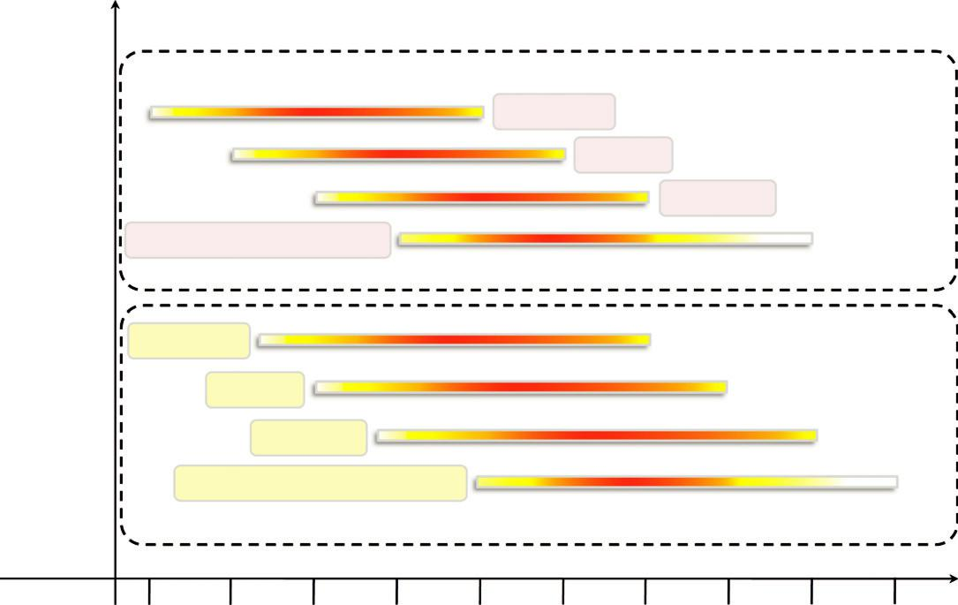

 | Architectures
Sequential Era | Compilers
 | Applications
 | Problem-Solving Environments
 | Architectures
 | Compilers
Parallel Era | Applications
 | Problem-Solving Environments

1940 1950 1960 1970 1980 1990 2000 2010 2020 2030

FIGURE 2.1

Eras of computing, 1940s 2030s.

More precisely, the term parallel computing refers to a model in which the computation is divided among several processors sharing the same memory. The architecture of a parallel comput-ing system is often characterized by the homogeneity of components: each processor is of the same type and it has the same capability as the others. The shared memory has a single address space, which is accessible to all the processors. Parallel programs are then broken down into several units of execution that can be allocated to different processors and can communicate with each other by means of the shared memory. Originally we considered parallel systems only those architectures that featured multiple processors sharing the same physical memory and that were considered a sin-gle computer. Over time, these restrictions have been relaxed, and parallel systems now include all architectures that are based on the concept of shared memory, whether this is physically present or created with the support of libraries, specific hardware, and a highly efficient networking infrastruc-ture. For example, a cluster of which the nodes are connected through an InfiniBand network and configured with a distributed shared memory system can be considered a parallel system.

The term distributed computing encompasses any architecture or system that allows the compu-tation to be broken down into units and executed concurrently on different computing elements, whether these are processors on different nodes, processors on the same computer, or cores within the same processor. Therefore, distributed computing includes a wider range of systems and appli-cations than parallel computing and is often considered a more general term. Even though it is nota rule, the term distributed often implies that the locations of the computing elements are not the same and such elements might be heterogeneous in terms of hardware and software features. Classic examples of distributed computing systems are computing grids or Internet computing sys-tems, which combine together the biggest variety of architectures, systems, and applications in the world.

Elements of parallel computing

It is now clear that silicon-based processor chips are reaching their physical limits. Processing speed is constrained by the speed of light, and the density of transistors packaged in a processor is constrained by thermodynamic limitations. A viable solution to overcome this limitation is to connect multiple processors working in coordination with each other to solve “Grand Challenge” problems. The first steps in this direction led to the development of parallel computing, which encompasses techniques, architectures, and systems for performing multiple activities in parallel. As we already discussed, the term parallel computing has blurred its edges with the term distrib-uted computing and is often used in place of the latter term. In this section, we refer to its proper characterization, which involves the introduction of

parallelism within a single computer by coordi-nating the activity of multiple processors together.

What is parallel processing?

Processing of multiple tasks simultaneously on multiple processors is called parallel processing. The parallel program consists of multiple active processes (tasks) simultaneously solving a given problem. A given task is divided into multiple subtasks using a divide-and-conquer technique, and each subtask is processed on a different central processing unit (CPU). Programming on a multipro-cessor system using the divide-and-conquer technique is called parallel programming.

Many applications today require more computing power than a traditional sequential computer can offer. Parallel processing provides a cost-effective solution to this problem by increasing the number of CPUs in a computer and by adding an efficient communication system between them. The workload can then be shared between different processors. This setup results in higher comput-ing power and performance than a single-processor system offers.

The development of parallel processing is being influenced by many factors. The prominent among them include the following:

- Computational requirements are ever increasing in the areas of both scientific and business computing. The technical computing problems, which require high-speed computational power, are related to life sciences, aerospace, geographical information systems, mechanical design and analysis, and the like.

- Sequential architectures are reaching physical limitations as they are constrained by the speed of light and thermodynamics laws. The speed at which sequential CPUs can operate is reaching saturation point (no more vertical growth), and hence an alternative way to get high computational speed is to connect multiple CPUs (opportunity for horizontal growth).

- Hardware improvements in pipelining, superscalar, and the like are nonscalable and require sophisticated compiler technology. Developing such compiler technology is a difficult task.
- Vector processing works well for certain kinds of problems. It is suitable mostly for scientific problems (involving lots of matrix operations) and graphical processing. It is not useful for other areas, such as databases.
- The technology of parallel processing is mature and can be exploited commercially; there is already significant R&D work on development tools and environments.
- Significant development in networking technology is paving the way for heterogeneous computing.

Hardware architectures for parallel processing

The core elements of parallel processing are CPUs. Based on the number of instruction and data streams that can be processed simultaneously, computing systems are classified into the following four categories:
- Single-instruction, single-data (SISD) systems
- Single-instruction, multiple-data (SIMD) systems
- Multiple-instruction, single-data (MISD) systems
- Multiple-instruction, multiple-data (MIMD) systems

Single-instruction, single-data (SISD) systems
An SISD computing system is a uniprocessor machine capable of executing a single instruction, which operates on a single data stream (see Figure 2.2). In SISD, machine instructions are pro-cessed sequentially; hence computers adopting this model are popularly called sequential compu-ters. Most conventional computers are built using the SISD model. All the instructions and data to be processed have to be stored in primary memory. The speed of the processing element in the SISD model is limited by the rate at which the computer can transfer information internally. Dominant representative SISD systems are IBM PC, Macintosh, and workstations.
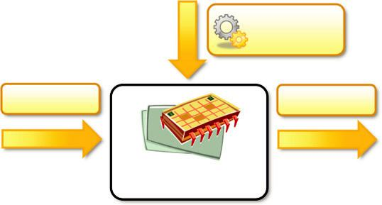

Instruction

Stream

Data Input Data Output

Processor

FIGURE 2.2

Single-instruction, single-data (SISD) architecture.

An SIMD computing system is a multiprocessor machine capable of executing the same instruction on all the CPUs but operating on different data streams (see Figure 2.3). Machines based on an SIMD model are well suited to scientific computing since they involve lots of vector and matrix operations. For instance, statements such as

Ci 5 Ai Bi

Single-instruction, multiple-data (SIMD) systems

can be passed to all the processing elements (PEs); organized data elements of vectors A and B can be divided into multiple sets (N-sets for N PE systems); and each PE can process one data set. Dominant representative SIMD systems are Cray’s vector processing machine and Thinking Machines’ cm .

Multiple-instruction, single-data (MISD) systems

An MISD computing system is a multiprocessor machine capable of executing different instructions on different PEs but all of them operating on the same data set (see Figure 2.4). For instance, state-ments such as

- 5 sinðxÞ 1 cosðxÞ 1 tanðxÞ
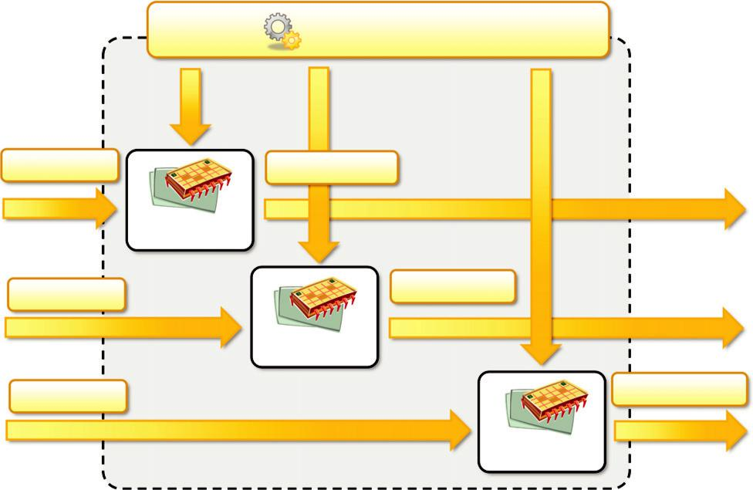

Single Instruction Stream

Data Input 1 | Data Output 1
 | Processor 1
Data Input 2 | Data Output 2
 | Processor 2
Data Input N | Data Output N
 | Processor N

FIGURE 2.3

Single-instruction, multiple-data (SIMD) architecture.
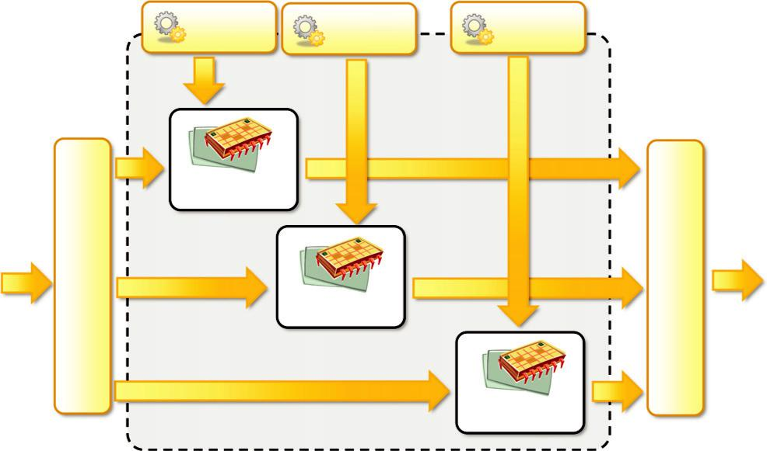

Instruction | Instruction | Instruction
Stream 1 | Stream 2 | Stream N

 | Processor 1
Input Stream
SingleData | Processor 2

Processor N

FIGURE 2.4

Multiple-instruction, single-data (MISD) architecture.

Single Data Output Stream

perform different operations on the same data set. Machines built using the MISD model are not useful in most of the applications; a few machines are built, but none of them are available com-mercially. They became more of an intellectual exercise than a practical configuration.

Multiple-instruction, multiple-data (MIMD) systems

An MIMD computing system is a multiprocessor machine capable of executing multiple instruc-tions on multiple data sets (see Figure 2.5). Each PE in the MIMD model has separate instruction and data streams; hence machines built using this model are well suited to any kind of application. Unlike SIMD and MISD machines, PEs in MIMD machines work asynchronously.

MIMD machines are broadly categorized into shared-memory MIMD and distributed-memory MIMD based on the way PEs are coupled to the main memory.

Shared memory MIMD machines

In the shared memory MIMD model, all the PEs are connected to a single global memory and they all have access to it (see Figure 2.6). Systems based on this model are also called tightly coupled multiprocessor systems. The communication between PEs in this model takes place through the shared memory; modification of the data stored in the global memory by one PE is visible to all other PEs. Dominant representative shared memory MIMD systems are Silicon Graphics machines and Sun/IBM’s SMP (Symmetric Multi-Processing).

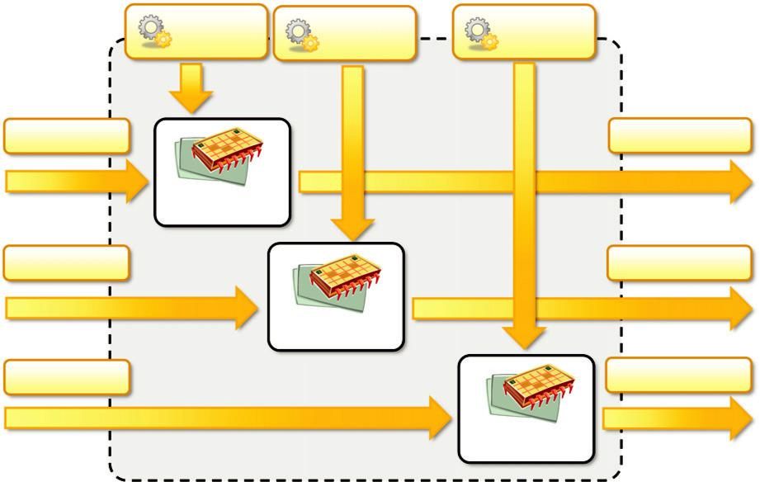

 | Instruction | Instruction | Instruction
 | Stream 1 | Stream 2 | Stream N
Data Input 1 |  |  |  | Data Output 1
 | Processor 1
Data Input 2 |  |  |  | Data Output 2
 |  | Processor 2
Data Input N |  |  |  | Data Output 3
 |  |  | Processor N
FIGURE 2.5
Multiple-instructions, multiple-data (MIMD) architecture.
 |  | IPC Channel |  | IPC Channel
Processor 1 Processor 2 | Processor N |  | Processor 2 | Processor 2
 | Memory | Processor 1 | Processor 2 | Processor 2
 | Memory | Memory | Memory | Memory
 | Bus | Memory | Memory | Memory
 | Bus | Bus | Bus | Bus
Global System Memory |  | Local | Local | Local
 |  | Memory | Memory | Memory
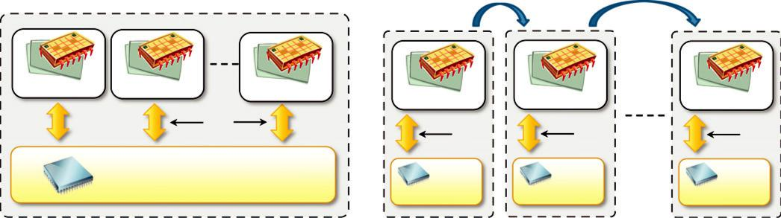

FIGURE 2.6

Shared (left) and distributed (right) memory MIMD architecture.

Distributed memory MIMD machines

In the distributed memory MIMD model, all PEs have a local memory. Systems based on this model are also called loosely coupled multiprocessor systems. The communication between PEs in this model takes place through the interconnection network (the interprocess communication channel, or IPC). The network connecting PEs can be configured to tree, mesh, cube, and so on. Each PE operates asynchronously, and if communication/synchronization among tasks is necessary, they can do so by exchanging messages between them.

The shared-memory MIMD architecture is easier to program but is less tolerant to failures and harder to extend with respect to the distributed memory MIMD model. Failures in a shared-memory MIMD affect the entire system, whereas this is not the case of the distributed model, in which each of the PEs can be easily isolated. Moreover, shared memory MIMD architectures are less likely to scale because the addition of more PEs leads to memory conten-tion. This is a situation that does not happen in the case of distributed memory, in which each PE has its own memory. As a result, distributed memory MIMD architectures are most popular today.

Approaches to parallel programming

A sequential program is one that runs on a single processor and has a single line of control. To make many processors collectively work on a single program, the program must be divided into smaller independent chunks so that each processor can work on separate chunks of the problem. The program decomposed in this way is a parallel program.

A wide variety of parallel programming approaches are available. The most prominent among them are the following:

Data parallelism

Process parallelism

Farmer-and-worker model

These three models are all suitable for task-level parallelism. In the case of data parallelism, the divide-and-conquer technique is used to split data into multiple sets, and each data set is processed on different PEs using the same instruction. This approach is highly suitable to processing on machines based on the SIMD model. In the case of process parallelism, a given operation has mul-tiple (but distinct) activities that can be processed on multiple processors. In the case of the farmer-and-worker model, a job distribution approach is used: one processor is configured as master and all other remaining PEs are designated as slaves; the master assigns jobs to slave PEs and, on com-pletion, they inform the master, which in turn collects results. These approaches can be utilized in different levels of parallelism.

Levels of parallelism

Levels of parallelism are decided based on the lumps of code (grain size) that can be a potential candidate for parallelism. Table 2.1 lists categories of code granularity for parallelism. All these approaches have a common goal: to boost processor efficiency by hiding latency. To conceal latency, there must be another thread ready to run whenever a lengthy operation occurs. The idea is to execute concurrently two or more single-threaded applications, such as compiling, text format-ting, database searching, and device simulation.

As shown in the table and depicted in Figure 2.7, parallelism within an application can be detected at several levels:

- Large grain (or task level)

- Medium grain (or control level)
37


Table 2.1 Levels of Parallelism

Grain Size | Code Item |  | Parallelized By
Large | Separate and heavyweight process |  | Programmer
Medium | Function or procedure |  | Programmer
Fine | Loop or instruction block |  | Parallelizing compiler
Very fine | Instruction |  | Processor
 | Messages | Messages
 | IPC | IPC | Large Level
 |  |  | (Processes, Tasks)
Task 1 | Task 2 | Task N
 | Shared | Shared
function f1() | _{Memory} function f2() | _{Memory} function fJ() | Medium Level
{…} | {…} | {…} | Medium Level
Function 1 | Function 2 | Function J | (Threads, Functions)
a[0] = … | a[1] = … | a[k] = … | Fine Level
b[0] = … | b[1] = … | b[k] = … | (Processor,
Statements | Statements | Statements | Instructions)
 |  |  | Very Fine Level
+ | x | load | (Cores, Pipeline,
+ | x | load | Instructions)
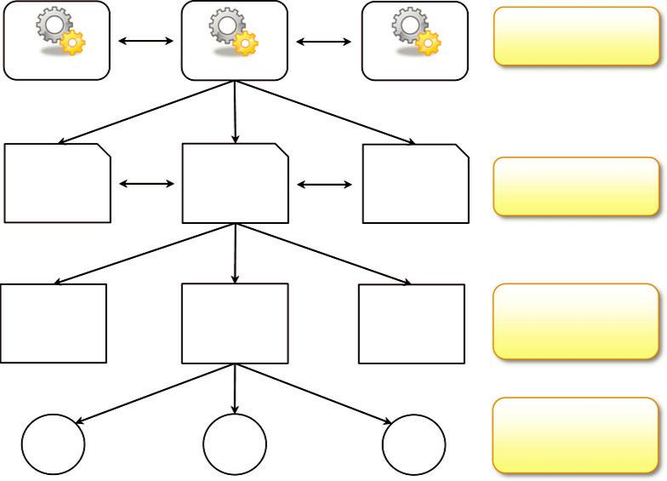

FIGURE 2.7

Levels of parallelism in an application.

- Fine grain (data level)

- Very fine grain (multiple-instruction issue)

In this book, we consider parallelism and distribution at the top two levels, which involve the distribution of the computation among multiple threads or processes.

Laws of caution

Now that we have introduced some general aspects of parallel computing in terms of architectures and models, we can make some considerations that have been drawn from experience designing and implementing such systems. These considerations are guidelines that can help us understand

how much benefit an application or a software system can gain from parallelism. In particular, what we need to keep in mind is that parallelism is used to perform multiple activities together so that the system can increase its throughput or its speed. But the relations that control the increment of speed are not linear. For example, for a given n processors, the user expects speed to be increased by n times. This is an ideal situation, but it rarely happens because of the communication overhead.

Here are two important guidelines to take into account:

- Speed of computation is proportional to the square root of system cost; they never increase linearly. Therefore, the faster a system becomes, the more expensive it is to increase its speed (Figure 2.8).

- Speed by a parallel computer increases as the logarithm of the number of processors (i.e., y 5 k log(N)). This concept is shown in Figure 2.9.
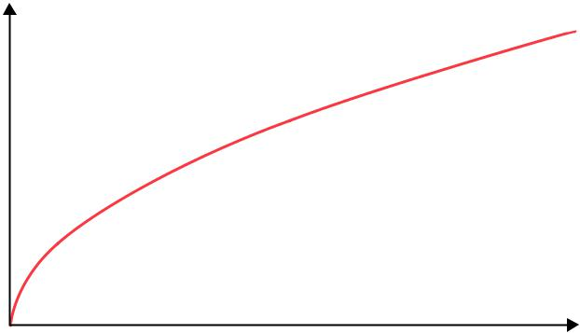

Speed (GHz)

FIGURE 2.8

Cost versus speed.

7

6

5

4

3

2

1

0

Cost ($)

Speed
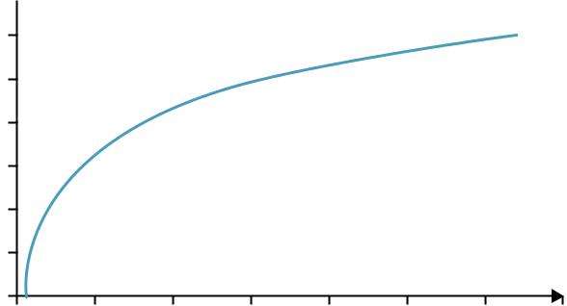

# Processors

0 10 20 30 40 50 60 70

FIGURE 2.9

Number processors versus speed.

The very fast development in parallel processing and related areas has blurred conceptual bound-aries, causing a lot of terminological confusion. Even well-defined distinctions such as shared memory and distributed memory are merging due to new advances in technology. There are no strict delimiters for contributors to the area of parallel processing. Hence, computer architects, OS designers, language designers, and computer network designers all have a role to play.

Elements of distributed computing

In the previous section, we discussed techniques and architectures that allow introduction of paral-lelism within a single machine or system and how parallelism operates at different levels of the computing stack. In this section, we extend these concepts and explore how multiple activities can be performed by leveraging systems composed of multiple heterogeneous machines and systems. We discuss what is generally referred to as distributed computing and more precisely introduce the most common guidelines and patterns for implementing distributed computing systems from the perspective of the software designer.

General concepts and definitions

Distributed computing studies the models, architectures, and algorithms used for building and man-aging distributed systems. As a general definition of the term distributed system, we use the one proposed by Tanenbaum et. al [1]:

A distributed system is a collection of independent computers that appears to its users as a single coherent system.

This definition is general enough to include various types of distributed computing systems that are especially focused on unified usage and aggregation of distributed resources. In this chapter, we focus on the architectural models that are used to harness independent computers and present them as a whole coherent system. Communication is another fundamental aspect of distributed comput-ing. Since distributed systems are composed of more than one computer that collaborate together, it is necessary to provide some sort of data and information exchange between them, which generally occurs through the network (Coulouris et al. [2]):

A distributed system is one in which components located at networked computers communicate and coordinate their actions only by passing messages.

As specified in this definition, the components of a distributed system communicate with some sort of message passing. This is a term that encompasses several communication models.

Components of a distributed system

A distributed system is the result of the interaction of several components that traverse the entire computing stack from hardware to software. It emerges from the collaboration of several elements that—by working together—give users the illusion of a single coherent system. Figure 2.10 provides an overview of the different layers that are involved in providing the services of a distributed system.
- CHAPTER 2 Principles of Parallel and Distributed Computing
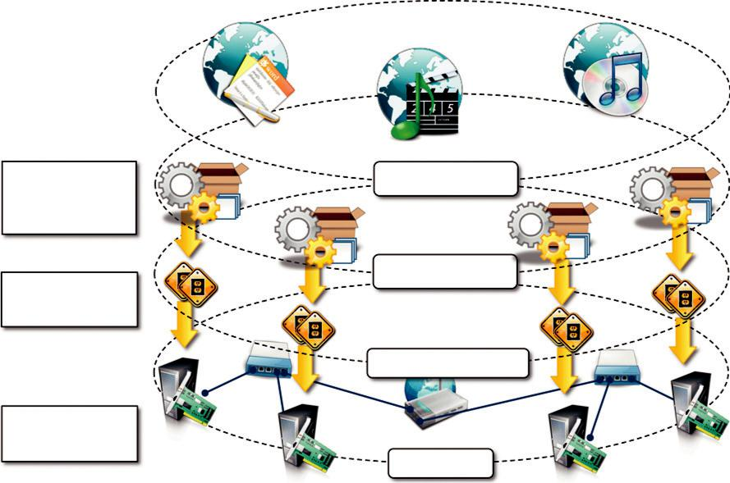

Frameworks for | Applications
Distributed
Programming
IPC Primitives for | Middleware
Control and Data
 | Operating System
Networking and
Parallel Hardware
 | Hardware

FIGURE 2.10

A layered view of a distributed system.

At the very bottom layer, computer and network hardware constitute the physical infrastructure; these components are directly managed by the operating system, which provides the basic services for interprocess communication (IPC), process scheduling and management, and resource manage-ment in terms of file system and local devices. Taken together these two layers become the plat-form on top of which specialized software is deployed to turn a set of networked computers into a distributed system.

The use of well-known standards at the operating system level and even more at the hardware and network levels allows easy harnessing of heterogeneous components and their organization into a coherent and uniform system. For example, network connectivity between different devices is controlled by standards, which allow them to interact seamlessly. At the operating system level, IPC services are implemented on top of standardized communication protocols such Transmission Control Protocol/Internet Protocol (TCP/IP), User Datagram Protocol (UDP) or others.

The middleware layer leverages such services to build a uniform environment for the develop-ment and deployment of distributed applications. This layer supports the programming paradigms for distributed systems, which we will discuss in Chapters 5 7 of this book. By relying on the ser-vices offered by the operating system, the middleware develops its own protocols, data formats, and programming language or frameworks for the development of distributed applications. All of them constitute a uniform interface to distributed application developers that is completely indepen-dent from the underlying operating system and hides all the heterogeneities of the bottom layers.

The top of the distributed system stack is represented by the applications and services designed and developed to use the middleware. These can serve several purposes and often expose their
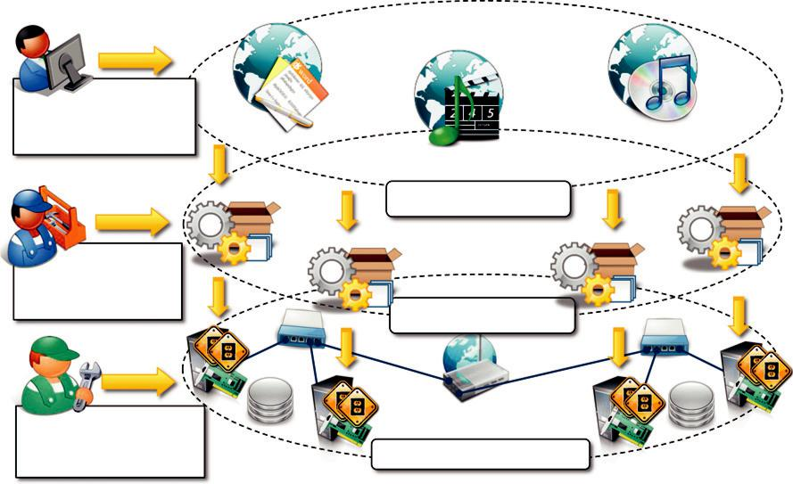

Social Networks,

Scientific Computing,

Enterprise Applications

Applications (SaaS)

Frameworks for

Cloud Application
Development
Middleware (PaaS)

Virtual Hardware,
Networking, OS Images, _{Hardware and OS (IaaS)}
and Storage

FIGURE 2.11

A cloud computing distributed system.

features in the form of graphical user interfaces (GUIs) accessible locally or through the Internet via a Web browser. For example, in the case of a cloud computing system, the use of Web technol-ogies is strongly preferred, not only to interface distributed applications with the end user but also to provide platform services aimed at building distributed systems. A very good example is consti-tuted by Infrastructure-as-a-Service (IaaS) providers such as Amazon Web Services (AWS), which provide facilities for creating virtual machines, organizing them together into a cluster, and deploy-ing applications and systems on top. Figure 2.11 shows an example of how the general reference architecture of a distributed system is contextualized in the case of a cloud computing system.

Note that hardware and operating system layers make up the bare-bone infrastructure of one or more datacenters, where racks of servers are deployed and connected together through high-speed connectivity. This infrastructure is managed by the operating system, which provides the basic capability of machine and network management. The core logic is then implemented in the middle-ware that manages the virtualization layer, which is deployed on the physical infrastructure in order to maximize its utilization and provide a customizable runtime environment for applications. The middleware provides different facilities to application developers according to the type of services sold to customers. These facilities, offered through Web 2.0-compliant interfaces, range from vir-tual infrastructure building and deployment to application development and runtime environments.

Architectural styles for distributed computing

Although a distributed system comprises the interaction of several layers, the middleware layer is the one that enables distributed computing, because it provides a coherent and uniform runtime environment for applications. There are many different ways to organize the components that, taken together, constitute such an environment. The interactions among these components and their

responsibilities give structure to the middleware and characterize its type or, in other words, define its architecture. Architectural styles [104] aid in understanding and classifying the organization of software systems in general and distributed computing in particular.

Architectural styles are mainly used to determine the vocabulary of components and connectors that are used as instances of the style together with a set of constraints on how they can be com-bined [105].

Design patterns [106] help in creating a common knowledge within the community of software engineers and developers as to how to structure the relations of components within an application and understand the internal organization of software applications. Architectural styles do the same for the overall architecture of software systems. In this section, we introduce the most relevant architectural styles for distributed computing and focus on the components and connectors that make each style peculiar. Architectural styles for distributed systems are helpful in understanding the different roles of components in the system and how they are distributed across multiple machines. We organize the architectural styles into two major classes:

Software architectural styles

System architectural styles

The first class relates to the logical organization of the software; the second class includes all those styles that describe the physical organization of distributed software systems in terms of their major components.

Component and connectors

Before we discuss the architectural styles in detail, it is important to build an appropriate vocabu-lary on the subject. Therefore, we clarify what we intend for components and connectors, since these are the basic building blocks with which architectural styles are defined. A component repre-sents a unit of software that encapsulates a function or a feature of the system. Examples of compo-nents can be programs, objects, processes, pipes, and filters. A connector is a communication mechanism that allows cooperation and coordination among components. Differently from compo-nents, connectors are not encapsulated in a single entity, but they are implemented in a distributed manner over many system components.

Software architectural styles

Software architectural styles are based on the logical arrangement of software components. They are helpful because they provide an intuitive view of the whole system, despite its physical deploy-ment. They also identify the main abstractions that are used to shape the components of the system and the expected interaction patterns between them. According to Garlan and Shaw [105], architec-tural styles are classified as shown in Table 2.2.

These models constitute the foundations on top of which distributed systems are designed from a logical point of view, and they are discussed in the following sections.

Data centered architectures

These architectures identify the data as the fundamental element of the software system, and access to shared data is the core characteristic of the data-centered architectures. Therefore, especially



Table 2.2 Software Architectural Styles

Category | Most Common Architectural Styles
Data-centered | Repository
 | Blackboard
Data flow | Pipe and filter
 | Batch sequential
Virtual machine | Rule-based system
 | Interpreter
Call and return | Main program and subroutine call/top-down systems
 | Object-oriented systems
 | Layered systems
Independent components | Communicating processes
 | Event systems

within the context of distributed and parallel computing systems, integrity of data is the overall goal for such systems.

The repository architectural style is the most relevant reference model in this category. It is characterized by two main components: the central data structure, which represents the current state of the system, and a collection of independent components, which operate on the central data. The ways in which the independent components interact with the central data structure can be very het-erogeneous. In particular, repository-based architectures differentiate and specialize further into subcategories according to the choice of control discipline to apply for the shared data structure. Of particular interest are databases and blackboard systems. In the former group the dynamic of the system is controlled by the independent components, which, by issuing an operation on the central repository, trigger the selection of specific processes that operate on data. In blackboard systems, the central data structure is the main trigger for selecting the processes to execute.
The blackboard architectural style is characterized by three main components:

- Knowledge sources. These are the entities that update the knowledge base that is maintained in the blackboard.

- Blackboard. This represents the data structure that is shared among the knowledge sources and stores the knowledge base of the application.

- Control. The control is the collection of triggers and procedures that govern the interaction with the blackboard and update the status of the knowledge base.

Within this reference scenario, knowledge sources, which represent the intelligent agents shar-ing the blackboard, react opportunistically to changes in the knowledge base, almost in the same way that a group of specialists brainstorm in a room in front of a blackboard. Blackboard models have become popular and widely used for artificial intelligent applications in which the blackboard maintains the knowledge about a domain in the form of assertions and rules, which are entered by domain experts. These operate through a control shell that controls the problem-solving activity of the system. Particular and successful applications of this model can be found in the domains of speech recognition and signal processing.

Data-flow architectures

In the case of data-flow architectures, it is the availability of data that controls the computation. With respect to the data-centered styles, in which the access to data is the core feature, data-flow styles explicitly incorporate the pattern of data flow, since their design is determined by an orderly motion of data from component to component, which is the form of communication between them. Styles within this category differ in one of the following ways: how the control is exerted, the degree of concurrency among components, and the topology that describes the flow of data.

Batch Sequential Style. The batch sequential style is characterized by an ordered sequence of separate programs executing one after the other. These programs are chained together by providing as input for the next program the output generated by the last program after its completion, which is most likely in the form of a file. This design was very popular in the mainframe era of comput-ing and still finds applications today. For example, many distributed applications for scientific computing are defined by jobs expressed as sequences of programs that, for example, pre-filter, analyze, and post-process data. It is very common to compose these phases using the batch-sequential style.

Pipe-and-Filter Style. The pipe-and-filter style is a variation of the previous style for expres-sing the activity of a software system as sequence of data transformations. Each component of the processing chain is called a filter, and the connection between one filter and the next is represented by a data stream. With respect to the batch sequential style, data is processed incrementally and each filter processes the data as soon as it is available on the input stream. As soon as one filter produces a consumable amount of data, the next filter can start its processing. Filters generally do not have state, know the identity of neither the previous nor the next filter, and they are connected with in-memory data structures such as first-in/first-out (FIFO) buffers or other structures. This par-ticular sequencing is called pipelining and introduces concurrency in the execution of the filters. A classic example of this architecture is the microprocessor pipeline, whereby multiple instructions are executed at the same time by completing a different phase of each of them. We can identify the phases of the instructions as the filters, whereas the data streams are represented by the registries that are shared within the processors. Another example are the Unix shell pipes (i.e., cat ,file-name.j grep,pattern.j wc l), where the filters are the single shell programs composed together and the connections are their input and output streams that are chained together. Applications of this architecture can also be found in the compiler design (e.g., the lex/yacc model is based on a pipe of the following phases: scanning j parsing j semantic analysis j code generation), image and signal processing, and voice and video streaming.

Data-flow architectures are optimal when the system to be designed embodies a multistage pro-cess, which can be clearly identified into a collection of separate components that need to be orchestrated together. Within this reference scenario, components have well-defined interfaces exposing input and output ports, and the connectors are represented by the datastreams between these ports. The main differences between the two subcategories are reported in Table 2.3.

Virtual machine architectures

The virtual machine class of architectural styles is characterized by the presence of an abstract exe-cution environment (generally referred as a virtual machine) that simulates features that are not available in the hardware or software. Applications and systems are implemented on top of this layer and become portable over different hardware and software environments as long as there is


Table 2.3 Comparison Between Batch Sequential and Pipe-and-Filter Styles

Batch Sequential | Pipe-and-Filter
Coarse grained | Fine grained
High latency | Reduced latency due to the incremental processing of input
External access to input | Localized input
No concurrency | Concurrency possible
Noninteractive | Interactivity awkward but possible

an implementation of the virtual machine they interface with. The general interaction flow for sys-tems implementing this pattern is the following: the program (or the application) defines its opera-tions and state in an abstract format, which is interpreted by the virtual machine engine. The interpretation of a program constitutes its execution. It is quite common in this scenario that the engine maintains an internal representation of the program state. Very popular examples within this category are rule-based systems, interpreters, and command-language processors.

Rule-Based Style. This architecture is characterized by representing the abstract execution envi-ronment as an inference engine. Programs are expressed in the form of rules or predicates that hold true. The input data for applications is generally represented by a set of assertions or facts that the inference engine uses to activate rules or to apply predicates, thus transforming data. The output can either be the product of the rule activation or a set of assertions that holds true for the given input data. The set of rules or predicates identifies the knowledge base that can be queried to infer properties about the system. This approach is quite peculiar, since it allows expressing a system or a domain in terms of its behavior rather than in terms of the components. Rule-based systems are very popular in the field of artificial intelligence. Practical applications can be found in the field of process control, where rule-based systems are used to monitor the status of physical devices by being fed from the sensory data collected and processed by PLCs¹ and by activating alarms when specific conditions on the sensory data apply. Another interesting use of rule-based systems can be found in the networking domain: network intrusion detection systems (NIDS) often rely on a set of rules to identify abnormal behaviors connected to possible intrusions in computing systems.

Interpreter Style. The core feature of the interpreter style is the presence of an engine that is used to interpret a pseudo-program expressed in a format acceptable for the interpreter. The inter-pretation of the pseudo-program constitutes the execution of the program itself. Systems modeled according to this style exhibit four main components: the interpretation engine that executes the core activity of this style, an internal memory that contains the pseudo-code to be interpreted, a representation of the current state of the engine, and a representation of the current state of the pro-gram being executed. This model is quite useful in designing virtual machines for high-level pro-gramming (Java, C#) and scripting languages (Awk, PERL, and so on). Within this scenario, the

virtual machine closes the gap between the end-user abstractions and the software/hardware envi-ronment in which such abstractions are executed.

Virtual machine architectural styles are characterized by an indirection layer between applica-tions and the hosting environment. This design has the major advantage of decoupling applications from the underlying hardware and software environment, but at the same time it introduces some disadvantages, such as a slowdown in performance. Other issues might be related to the fact that, by providing a virtual execution environment, specific features of the underlying system might not be accessible.

Call & return architectures

This category identifies all systems that are organised into components mostly connected together by method calls. The activity of systems modeled in this way is characterized by a chain of method calls whose overall execution and composition identify the execution of one or more operations. The internal organization of components and their connections may vary. Nonetheless, it is possible to identify three major subcategories, which differentiate by the way the system is structured and how methods are invoked: top-down style, object-oriented style, and layered style.

Top-Down Style. This architectural style is quite representative of systems developed with imperative programming, which leads to a divide-and-conquer approach to problem resolution. Systems developed according to this style are composed of one large main program that accom-plishes its tasks by invoking subprograms or procedures. The components in this style are proce-dures and subprograms, and connections are method calls or invocation. The calling program passes information with parameters and receives data from return values or parameters. Method calls can also extend beyond the boundary of a single process by leveraging techniques for remote method invocation, such as remote procedure call (RPC) and all its descendants. The overall struc-ture of the program execution at any point in time is characterized by a tree, the root of which con-stitutes the main function of the principal program. This architectural style is quite intuitive from a design point of view but hard to maintain and manage in large systems.

Object-Oriented Style. This architectural style encompasses a wide range of systems that have been designed and implemented by leveraging the abstractions of object-oriented programming (OOP). Systems are specified in terms of classes and implemented in terms of objects. Classes define the type of components by specifying the data that represent their state and the operations that can be done over these data. One of the main advantages over the top-down style is that there is a coupling between data and operations used to manipulate them. Object instances become responsible for hiding their internal state representation and for protecting its integrity while provid-ing operations to other components. This leads to a better decomposition process and more manage-able systems. Disadvantages of this style are mainly two: each object needs to know the identity of an object if it wants to invoke operations on it, and shared objects need to be carefully designed in order to ensure the consistency of their state.

Layered Style. The layered system style allows the design and implementation of software sys-tems in terms of layers, which provide a different level of abstraction of the system. Each layer generally operates with at most two layers: the one that provides a lower abstraction level and the one that provides a higher abstraction layer. Specific protocols and interfaces define how adjacent layers interact. It is possible to model such systems as a stack of layers, one for each level of abstraction. Therefore, the components are the layers and the connectors are the interfaces and

protocols used between adjacent layers. A user or client generally interacts with the layer at the highest abstraction, which, in order to carry its activity, interacts and uses the services of the lower layer. This process is repeated (if necessary) until the lowest layer is reached. It is also possible to have the opposite behavior: events and callbacks from the lower layers can trigger the activity of the higher layer and propagate information up through the stack. The advantages of the layered style are that, as happens for the object-oriented style, it supports a modular design of systems and allows us to decompose the system according to different levels of abstractions by encapsulating together all the operations that belong to a specific level. Layers can be replaced as long as they are compliant with the expected protocols and interfaces, thus making the system flexible. The main disadvantage is constituted by the lack of extensibility, since it is not possible to add layers without changing the protocols and the interfaces between layers.² This also makes it complex to add operations. Examples of layered architectures are the modern operating system kernels and the International Standards Organization/Open Systems Interconnection (ISO/OSI) or the TCP/IP stack.

Architectural styles based on independent components

This class of architectural style models systems in terms of independent components that have their own life cycles, which interact with each other to perform their activities. There are two major cat-egories within this class—communicating processes and event systems—which differentiate in the way the interaction among components is managed.

Communicating Processes. In this architectural style, components are represented by indepen-dent processes that leverage IPC facilities for coordination management. This is an abstraction that is quite suitable to modeling distributed systems that, being distributed over a network of comput-ing nodes, are necessarily composed of several concurrent processes. Each of the processes pro-vides other processes with services and can leverage the services exposed by the other processes. The conceptual organization of these processes and the way in which the communication happens vary according to the specific model used, either peer-to-peer or client/server.³ Connectors are iden-tified by IPC facilities used by these processes to communicate.

Event Systems. In this architectural style, the components of the system are loosely coupled and connected. In addition to exposing operations for data and state manipulation, each component also publishes (or announces) a collection of events with which other components can register. In general, other components provide a callback that will be executed when the event is activated. During the activity of a component, a specific runtime condition can activate one of the exposed events, thus triggering the execution of the callbacks registered with it. Event activation may be accompanied by contextual information that can be used in the callback to handle the event. This information can be passed as an argument to the callback or by using some shared repository between components. Event-based systems have become quite popular, and support for their imple-mentation is provided either at the API level or the programming language level.⁴ The main

advantage of such an architectural style is that it fosters the development of open systems: new modules can be added and easily integrated into the system as long as they have compliant inter-faces for registering to the events. This architectural style solves some of the limitations observed for the top-down and object-oriented styles. First, the invocation pattern is implicit, and the connec-tion between the caller and the callee is not hard-coded; this gives a lot of flexibility since addition or removal of a handler to events can be done without changes in the source code of applications. Second, the event source does not need to know the identity of the event handler in order to invoke the callback. The disadvantage of such a style is that it relinquishes control over system computa-tion. When a component triggers an event, it does not know how many event handlers will be invoked and whether there are any registered handlers. This information is available only at runtime and, from a static design point of view, becomes more complex to identify the connections among components and to reason about the correctness of the interactions.

In this section, we reviewed the most popular software architectural styles that can be utilized as a reference for modeling the logical arrangement of components in a system. They are a subset of all the architectural styles; other styles can be found in [105].

System architectural styles

System architectural styles cover the physical organization of components and processes over a dis-tributed infrastructure. They provide a set of reference models for the deployment of such systems and help engineers not only have a common vocabulary in describing the physical layout of sys-tems but also quickly identify the major advantages and drawbacks of a given deployment and whether it is applicable for a specific class of applications. In this section, we introduce two funda-mental reference styles: client/server and peer-to-peer.

Client/server

This architecture is very popular in distributed computing and is suitable for a wide variety of applications. As depicted in Figure 2.12, the client/server model features two major components: a server and a client. These two components interact with each other through a network connection using a given protocol. The communication is unidirectional: The client issues a request to the server, and after processing the request the server returns a response. There could be multiple client components issuing requests to a server that is passively waiting for them. Hence, the important operations in the client-server paradigm are request, accept (client side), and listen and response (server side).

The client/server model is suitable in many-to-one scenarios, where the information and the services of interest can be centralized and accessed through a single access point: the server. In general, multiple clients are interested in such services and the server must be appropriately designed to efficiently serve requests coming from different clients. This consideration has impli-cations on both client design and server design. For the client design, we identify two major models:

- Thin-client model. In this model, the load of data processing and transformation is put on the server side, and the client has a light implementation that is mostly concerned with retrieving and returning the data it is being asked for, with no considerable further processing.
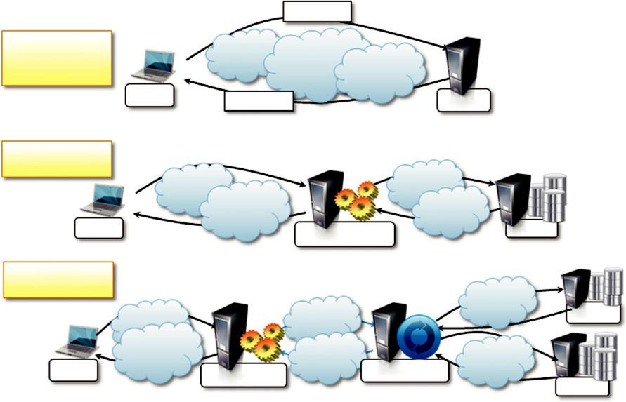

 |  | request
Two Tier
(Classic Model)
client | response |  | server
Three Tier
client |  | server/client | server
N Tier

server

client | server/client | server/client
server

FIGURE 2.12

Client/server architectural styles.

- Fat-client model. In this model, the client component is also responsible for processing and transforming the data before returning it to the user, whereas the server features a relatively light implementation that is mostly concerned with the management of access to the data.

The three major components in the client-server model: presentation, application logic, and data storage. In the thin-client model, the client embodies only the presentation component, while the server absorbs the other two. In the fat-client model, the client encapsulates presentation and most of the application logic, and the server is principally responsible for the data storage and maintenance.

Presentation, application logic, and data maintenance can be seen as conceptual layers, which are more appropriately called tiers. The mapping between the conceptual layers and their physical implementation in modules and components allows differentiating among several types of architec-tures, which go under the name of multitiered architectures. Two major classes exist:

- Two-tier architecture. This architecture partitions the systems into two tiers, which are located one in the client component and the other on the server. The client is responsible for the presentation tier by providing a user interface; the server concentrates the application logic and the data store into a single tier. The server component is generally deployed on a powerful machine that is capable of processing user requests, accessing data, and executing the application logic to provide a client with a response. This architecture is suitable for systems of limited size and suffers from scalability issues. In particular, as the number of users increases the performance of the server might dramatically decrease. Another limitation is caused by the

dimension of the data to maintain, manage, and access, which might be prohibitive for a single computation node or too large for serving the clients with satisfactory performance.

- Three-tier architecture/N-tier architecture. The three-tier architecture separates the presentation of data, the application logic, and the data storage into three tiers. This architecture is generalized into an N-tier model in case it is necessary to further divide the stages composing the application logic and storage tiers. This model is generally more scalable than the two-tier one because it is possible to distribute the tiers into several computing nodes, thus isolating the performance bottlenecks. At the same time, these systems are also more complex to understand and manage. A classic example of three-tier architecture is constituted by a medium-size Web application that relies on a relational database management system for storing its data. In this scenario, the client component is represented by a Web browser that embodies the presentation tier, whereas the application server encapsulates the business logic tier, and a database server machine (possibly replicated for high availability) maintains the data storage. Application servers that rely on third-party (or external) services to satisfy client requests are examples of N-tiered architectures.

The client/server architecture has been the dominant reference model for designing and deploying distributed systems, and several applications to this model can be found. The most rel-evant is perhaps the Web in its original conception. Nowadays, the client/server model is an important building block of more complex systems, which implement some of their features by identifying a server and a client process interacting through the network. This model is generally suitable in the case of a many-to-one scenario, where the interaction is unidirectional and started by the clients and suffers from scalability issues, and therefore it is not appropriate in very large systems.

Peer-to-peer

The peer-to-peer model, depicted in Figure 2.13, introduces a symmetric architecture in which all the components, called peers, play the same role and incorporate both client and server capabilities of the client/server model. More precisely, each peer acts as a server when it processes requests from other peers and as a client when it issues requests to other peers. With respect to the client/ server model that partitions the responsibilities of the IPC between server and clients, the peer-to-peer model attributes the same responsibilities to each component. Therefore, this model is quite suitable for highly decentralized architecture, which can scale better along the dimension of the number of peers. The disadvantage of this approach is that the management of the implementation of algorithms is more complex than in the client/server model.

The most relevant example of peer-to-peer systems [87] is constituted by file-sharing applica-tions such as Gnutella, BitTorrent, and Kazaa. Despite the differences among these networks in coordinating nodes and sharing information on the files and their locations, all of them provide a user client that is at the same time a server providing files to other peers and a client downloading files from other peers. To address an incredibly large number of peers, different architectures have been designed that divert slightly from the peer-to-peer model. For example, in Kazaa not all the peers have the same role, and some of them are used to group the accessibility information of a group of peers. Another interesting example of peer-to-peer architecture is represented by the Skype network.
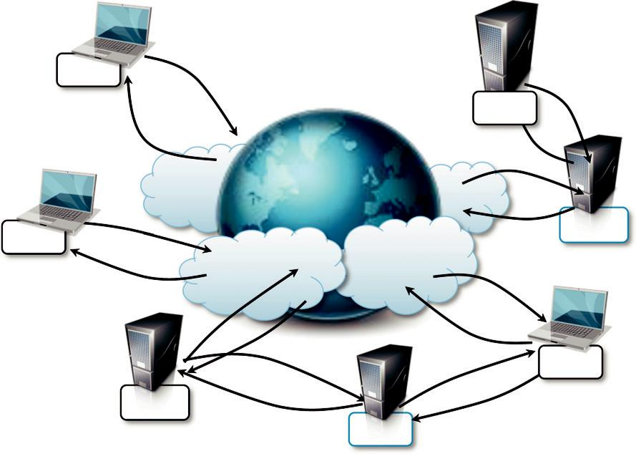

peer

peer

peer
peer

peer

peer

peer

FIGURE 2.13

Peer-to-peer architectural style.

The system architectural styles presented in this section constitute a reference model that is further enhanced or diversified according to the specific needs of the application to be designed and imple-mented. For example, the client/server architecture, which originally included only two types of components, has been further extended and enriched by developing multitier architectures as the complexity of systems increased. Currently, this model is still the predominant reference architec-ture for distributed systems and applications. The server and client abstraction can be used in some cases to model the macro scale or the micro scale of the systems. For peer-to-peer systems, pure implementations are very hard to find and, as discussed for the case of Kazaa, evolutions of the model, which introduced some kind of hierarchy among the nodes, are common.

Models for interprocess communication

Distributed systems are composed of a collection of concurrent processes interacting with each other by means of a network connection. Therefore, IPC is a fundamental aspect of distributed sys-tems design and implementation. IPC is used to either exchange data and information or coordinate the activity of processes. IPC is what ties together the different components of a distributed system, thus making them act as a single system. There are several different models in which processes can interact with each other; these map to different abstractions for IPC. Among the most relevant that we can mention are shared memory, remote procedure call (RPC), and message passing. At a lower level, IPC is realized through the fundamental tools of network programming. Sockets are the most popular IPC primitive for implementing communication channels between distributed processes.

They facilitate interaction patterns that, at the lower level, mimic the client/server abstraction and are based on a request-reply communication model. Sockets provide the basic capability of transfer-ring a sequence of bytes, which is converted at higher levels into a more meaningful representation (such as procedure parameters or return values or messages). Such a powerful abstraction allows system engineers to concentrate on the logic-coordinating distributed components and the informa-tion they exchange rather than the networking details. These two elements identify the model for IPC. In this section, we introduce the most important reference model for architecting the commu-nication among processes.

Message-based communication

The abstraction of message has played an important role in the evolution of the models and tech-nologies enabling distributed computing. Couloris et al. [2] define a distributed system as “one in which components located at networked computers communicate and coordinate their actions only by passing messages.” The term message, in this case, identifies any discrete amount of information that is passed from one entity to another. It encompasses any form of data representation that is limited in size and time, whereas this is an invocation to a remote procedure or a serialized object instance or a generic message. Therefore, the term message-based communication model can be used to refer to any model for IPC discussed in this section, which does not necessarily rely on the abstraction of data streaming.

Several distributed programming paradigms eventually use message-based communication despite the abstractions that are presented to developers for programming the interaction of distrib-uted components. Here are some of the most popular and important:

Message passing. This paradigm introduces the concept of a message as the main abstraction of the model. The entities exchanging information explicitly encode in the form of a message the data to be exchanged. The structure and the content of a message vary according to the model. Examples of this model are the Message-Passing Interface (MPI) and OpenMP.

Remote procedure call (RPC). This paradigm extends the concept of procedure call beyond the boundaries of a single process, thus triggering the execution of code in remote processes. In this case, underlying client/server architecture is implied. A remote process hosts a server component, thus allowing client processes to request the invocation of methods, and returns the result of the execution. Messages, automatically created by the RPC implementation, convey the information about the procedure to execute along with the required parameters and the return values. The use of messages within this context is also referred as marshaling of parameters and return values.

Distributed objects. This is an implementation of the RPC model for the object-oriented paradigm and contextualizes this feature for the remote invocation of methods exposed by objects. Each process registers a set of interfaces that are accessible remotely. Client processes can request a pointer to these interfaces and invoke the methods available through them. The underlying runtime infrastructure is in charge of transforming the local method invocation into a request to a remote process and collecting the result of the execution. The communication between the caller and the remote process is made through messages. With respect to the RPC model that is stateless by design, distributed object models introduce the complexity of object state management and lifetime. The methods that are remotely executed operate within the context of an instance, which may be created for the sole execution of the method, exist for a limited interval of time, or are

independent from the existence of requests. Examples of distributed object infrastructures are Common Object Request Broker Architecture (CORBA), Component Object Model (COM, DCOM, and COM1), Java Remote Method Invocation (RMI), and .NET Remoting.

- Distributed agents and active objects. Programming paradigms based on agents and active objects involve by definition the presence of instances, whether they are agents of objects, despite the existence of requests. This means that objects have their own control thread, which allows them to carry out their activity. These models often make explicit use of messages to trigger the execution of methods, and a more complex semantics is attached to the messages.

- Web services. Web service technology provides an implementation of the RPC concept over HTTP, thus allowing the interaction of components that are developed with different technologies. A Web service is exposed as a remote object hosted on a Web server, and method invocations are transformed in HTTP requests, opportunely packaged using specific protocols such as Simple Object Access Protocol (SOAP) or Representational State Transfer (REST).

It is important to observe that the concept of a message is a fundamental abstraction of IPC, and it is used either explicitly or implicitly. Messages’ principal use—in any of the cases dis-cussed—is to define interaction protocols among distributed components for coordinating their activity and exchanging data.

Models for message-based communication

We have seen how message-based communication constitutes a fundamental block for several dis-tributed programming paradigms. Another important aspect characterizing the interaction among distributed components is the way these messages are exchanged and among how many compo-nents. In several cases, we identified the client/server model as the underlying reference model for the interaction. This, in its strictest form, represents a point-to-point communication model allowing a many-to-one interaction pattern. Variations of the client/server model allow for different interac-tion patterns. In this section, we briefly discuss the most important and recurring ones.

Point-to-point message model

This model organizes the communication among single components. Each message is sent from one component to another, and there is a direct addressing to identify the message receiver. In a point-to-point communication model it is necessary to know the location of or how to address another component in the system. There is no central infrastructure that dispatches the messages, and the communication is initiated by the message sender. It is possible to identify two major sub-categories: direct communication and queue-based communication. In the former, the message is sent directly to the receiver and processed at the time of reception. In the latter, the receiver main-tains a message queue in which the messages received are placed for later processing. The point-to-point message model is useful for implementing systems that are mostly based on one-to-one or many-to-one communication.

Publish-and-subscribe message model

This model introduces a different strategy, one that is based on notification among components. There are two major roles: the publisher and the subscriber. The former provides facilities for the latter to register its interest in a specific topic or event. Specific conditions holding true on the pub-lisher side can trigger the creation of messages that are attached to a specific event. A message will

be available to all the subscribers that registered for the corresponding event. There are two major strategies for dispatching the event to the subscribers:

Push strategy. In this case it is the responsibility of the publisher to notify all the subscribers— for example, with a method invocation.

Pull strategy. In this case the publisher simply makes available the message for a specific event, and it is responsibility of the subscribers to check whether there are messages on the events that are registered.

The publish-and-subscribe model is very suitable for implementing systems based on the one-to-many communication model and simplifies the implementation of indirect communication pat-terns. It is, in fact, not necessary for the publisher to know the identity of the subscribers to make the communication happen.

Request-reply message model

The request-reply message model identifies all communication models in which, for each message sent by a process, there is a reply. This model is quite popular and provides a different classifica-tion that does not focus on the number of the components involved in the communication but rather on how the dynamic of the interaction evolves. Point-to-point message models are more likely to be based on a request-reply interaction, especially in the case of direct communication. Publish-and-subscribe models are less likely to be based on request-reply since they rely on notifications.

The models presented here constitute a reference for structuring the communication among compo-nents in a distributed system. It is very uncommon that one single mode satisfies all the communi-cation needs within a system. More likely, a composition of modes or their conjunct use in order to design and implement different aspects is the common case.

Technologies for distributed computing

In this section, we introduce relevant technologies that provide concrete implementations of interac-tion models, which mostly rely on message-based communication. They are remote procedure call (RPC), distributed object frameworks, and service-oriented computing.

Remote procedure call

RPC is the fundamental abstraction enabling the execution of procedures on client’s request. RPC allows extending the concept of a procedure call beyond the boundaries of a process and a single memory address space. The called procedure and calling procedure may be on the same system or they may be on different systems in a network. The concept of RPC has been discussed since 1976 and completely formalized by Nelson [111] and Birrell [112] in the early 1980s. From there on, it has not changed in its major components. Even though it is a quite old technology, RPC is still used today as a fundamental component for IPC in more complex systems.

Figure 2.14 illustrates the major components that enable an RPC system. The system is based on a client/server model. The server process maintains a registry of all the available procedures that
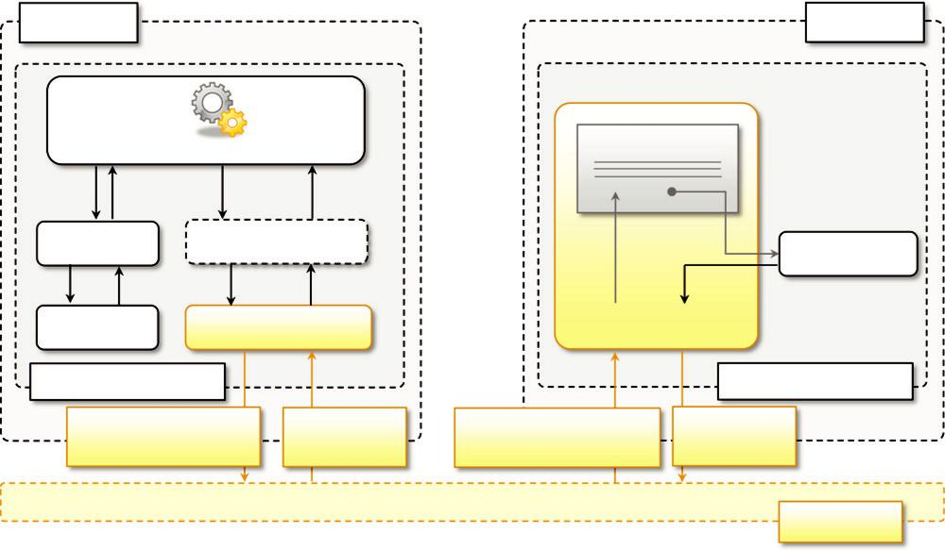

Node A

Main Procedure

Node B

Procedure Registry

Procedure A | Procedure C:Node B
 | Procedure C

Procedure B | RPC Library |  | RPC Service
Program A (RPC Client) |  |  |  | Program C (RPC Server)
Parameters Marshaling |  | Return Value | Parameters Unmarshaling | Return Value
and Procedure Name |  | Unmarshaling | and Procedure Name | Marshaling

Network

FIGURE 2.14

The RPC reference model.

can be remotely invoked and listens for requests from clients that specify which procedure to invoke, together with the values of the parameters required by the procedure. RPC maintains the synchronous pattern that is natural in IPC and function calls. Therefore, the calling process thread remains blocked until the procedure on the server process has completed its execution and the result (if any) is returned to the client.

An important aspect of RPC is marshaling, which identifies the process of converting parameter and return values into a form that is more suitable to be transported over a network through a sequence of bytes. The term unmarshaling refers to the opposite procedure. Marshaling and unmar-shaling are performed by the RPC runtime infrastructure, and the client and server user code does not necessarily have to perform these tasks. The RPC runtime, on the other hand, is not only responsible for parameter packing and unpacking but also for handling the request-reply interaction that happens between the client and the server process in a completely transparent manner. Therefore, developing a system leveraging RPC for IPC consists of the following steps:

- Design and implementation of the server procedures that will be exposed for remote invocation.

- Registration of remote procedures with the RPC server on the node where they will be made available.

- Design and implementation of the client code that invokes the remote procedure(s).

Each RPC implementation generally provides client and server application programming inter-faces (APIs) that facilitate the use of this simple and powerful abstraction. An important observa-tion has to be made concerning the passing of parameters and return values. Since the server and the client processes are in two separate address spaces, the use of parameters passed by references

or pointers is not suitable in this scenario, because once unmarshaled these will refer to a memory location that is not accessible from within the server process. Second, in user-defined parameters and return value types, it is necessary to ensure that the RPC runtime is able to marshal them. This is generally possible, especially when user-defined types are composed of simple types, for which marshaling is naturally provided.

RPC has been a dominant technology for IPC for quite a long time, and several programming languages and environments support this interaction pattern in the form of libraries and additional packages. For instance, RPyC is an RPC implementation for Python. There also exist platform-independent solutions such as XML-RPC and JSON-RPC, which provide RPC facilities over XML and JSON, respectively. Thrift [113] is the framework developed at Facebook for enabling a trans-parent cross-language RPC model. Currently, the term RPC implementations encompass a variety of solutions including frameworks such distributed object programming (CORBA, DCOM, Java RMI, and .NET Remoting) and Web services that evolved from the original RPC concept. We dis-cuss the peculiarity of these approaches in the following sections.

Distributed object frameworks

Distributed object frameworks extend object-oriented programming systems by allowing objects to be distributed across a heterogeneous network and provide facilities so that they can coherently act as though they were in the same address space. Distributed object frameworks leverage the basic mechanism introduced with RPC and extend it to enable the remote invocation of object methods and to keep track of references to objects made available through a network connection.

With respect to the RPC model, the infrastructure manages instances that are exposed through well-known interfaces instead of procedures. Therefore, the common interaction pattern is the following:

- The server process maintains a registry of active objects that are made available to other processes. According to the specific implementation, active objects can be published using interface definitions or class definitions.

- The client process, by using a given addressing scheme, obtains a reference to the active remote object. This reference is represented by a pointer to an instance that is of a shared type of interface and class definition.

- The client process invokes the methods on the active object by calling them through the reference previously obtained. Parameters and return values are marshaled as happens in the case of RPC.

Distributed object frameworks give the illusion of interaction with a local instance while invoking remote methods. This is done by a mechanism called a proxy skeleton. Figure 2.15 gives an overview of how this infrastructure works. Proxy and skeleton always constitute a pair: the server process maintains the skeleton component, which is in charge of executing the methods that are remotely invoked, while the client maintains the proxy component, allowing its hosting environment to remotely invoke methods through the proxy interface. The transparency of remote method invocation is achieved using one of the fundamental properties of object-oriented programming: inheritance and subclassing. Both the proxy and the active remote object expose the same interface, defining the set of methods that can be remotely called. On the client side, a runtime object subclassing the type pub-lished by the server is generated. This object translates the local method invocation into an RPC call
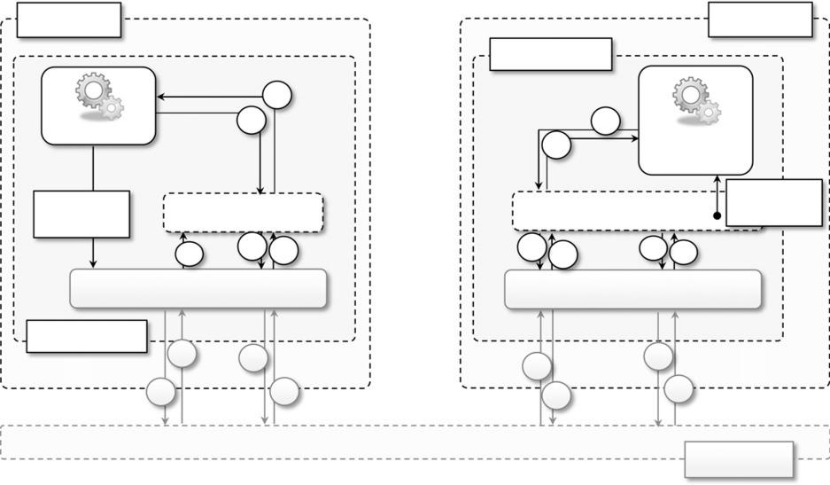

Node A | Node B
Application B
21
10 | 16
Instance | Remote
15 | Remote
 | Instance

5: Object
^{1: Ask for} Object Proxy Object Skeleton Activation Reference

9 | 11 | 20 | 17 | 14 | 6 | 4
Remote Reference Module |  |  | Remote Reference Module

Application A

8 | 12 | 13 | 7
2 | 19 | 18 | 3

Network

FIGURE 2.15

The distributed object programming model.

for the corresponding method on the remote active object. On the server side, whenever an RPC request is received, it is unpacked and the method call is dispatched to the skeleton that is paired with the client that issued the request. Once the method execution on the server is completed, the return values are packed and sent back to the client, and the local method call on the proxy returns.

Distributed object frameworks introduce objects as first-class entities for IPC. They are the prin-cipal gateway for invoking remote methods but can also be passed as parameters and return values. This poses an interesting problem, since object instances are complex instances that encapsulate a state and might be referenced by other components. Passing an object as a parameter or return value involves the duplication of the instance on the other execution context. This operation leads to two separate objects whose state evolves independently. The duplication becomes necessary since the instance needs to trespass the boundaries of the process. This is an important aspect to take into account in designing distributed object systems, because it might lead to inconsistencies. An alternative to this standard process, which is called marshaling by value, is marshaling by refer-ence. In this second case the object instance is not duplicated and a proxy of it is created on the server side (for parameters) or the client side (for return values). Marshaling by reference is a more complex technique and generally puts more burden on the runtime infrastructure since remote refer-ences have to be tracked. Being more complex and resource demanding, marshaling by reference should be used only when duplication of parameters and return values lead to unexpected and inconsistent behavior of the system.

Object activation and lifetime

The management of distributed objects poses additional challenges with respect to the simple invo-cation of a procedure on a remote node. Methods live within the context of an object instance, and

they can alter the internal state of the object as a side effect of their execution. In particular, the lifetime of an object instance is a crucial element in distributed object-oriented systems. Within a single memory address space scenario, objects are explicitly created by the programmer, and their references are made available by passing them from one object instance to another. The memory allocated for them can be explicitly reclaimed by the programmer or automatically by the runtime system when there are no more references to that instance. A distributed scenario introduces addi-tional issues that require a different management of the lifetime of objects exposed through remote interfaces.

The first element to be considered is the object’s activation, which is the creation of a remote object. Various strategies can be used to manage object activation, from which we can distinguish two major classes: server-based activation and client-based activation. In server-based activation, the active object is created in the server process and registered as an instance that can be exposed beyond process boundaries. In this case, the active object has a life of its own and occasionally exe-cutes methods as a consequence of a remote method invocation. In client-based activation the active object does not originally exist on the server side; it is created when a request for method invocation comes from a client. This scenario is generally more appropriate when the active object is meant to be stateless and should exist for the sole purpose of invoking methods from remote cli-ents. For example, if the remote object is simply a gateway to access and modify other components hosted within the server process, client-based activation is a more efficient pattern.

The second element to be considered is the lifetime of remote objects. In the case of server-based activation, the lifetime of an object is generally user-controlled, since the activation of the remote object is explicit and controlled by the user. In the case of client-based activation, the crea-tion of the remote object is implicit, and therefore its lifetime is controlled by some policy of the runtime infrastructure. Different policies can be considered; the simplest one implies the creation of a new instance for each method invocation. This solution is quite demanding in terms of object instances and is generally integrated with some lease management strategy that allows objects to be reused for subsequent method invocations if they occur within a specified time interval (lease). Another policy might consider having only a single instance at a time, and the lifetime of the object is then controlled by the number and frequency of method calls. Different frameworks provide dif-ferent levels of control of this aspect.

Object activation and lifetime management are features that are now supported to some extent in almost all the frameworks for distributed object programming, since they are essential to understand-ing the behavior of a distributed system. In particular, these two aspects are becoming fundamental in designing components that are accessible from other processes and that maintain states. Understanding how many objects representing the same component are created and for how long they last is essential in tracking inconsistencies due to erroneous updates to the instance internal data.

Examples of distributed object frameworks

The support for distributed object programming has evolved over time, and today it is a common feature of mainstream programming languages such as C# and Java, which provide these capabili-ties as part of the base class libraries. This level of integration is a sign of the maturity of this tech-nology, which originally was designed as a separate component that could be used in several programming languages. In this section, we briefly review the most relevant approaches to and technologies for distributed object programming.

Common object request broker architecture (CORBA)

CORBA is a specification introduced by the Object Management Group (OMG) for providing cross-platform and cross-language interoperability among distributed components. The specification was originally designed to provide an interoperation standard that could be effectively used at the indus-trial level. The current release of the CORBA specification is version 3.0 and currently the technology is not very popular, mostly because the development phase is a considerably complex task and the interoperability among components developed in different languages has never reached the proposed level of transparency. A fundamental component in the CORBA architecture is the Object Request Broker (ORB), which acts as a central object bus. A CORBA object registers with the ORB the inter-face it is exposing, and clients can obtain a reference to that interface and invoke methods on it. The ORB is responsible for returning the reference to the client and managing all the low-level operations required to perform the remote method invocation. To simplify cross-platform interoperability, inter-faces are defined in Interface Definition Language (IDL), which provides a platform-independent specification of a component. An IDL specification is then translated into a stub-skeleton pair by spe-cific CORBA compilers that generate the required client (stub) and server (skeleton) components in a specific programming language. These templates are completed with an appropriate implementation in the selected programming language. This allows CORBA components to be used across different runtime environment by simply using the stub and the skeleton that match the development language used. A specification meant to be used at the industry level, CORBA provides interoperability among different implementations of its runtime. In particular, at the lowest-level ORB implementations com-municate with each other using the Internet Inter-ORB Protocol (IIOP), which standardizes the inter-actions of different ORB implementations. Moreover, CORBA provides an additional level of abstraction and separates the ORB, which mostly deals with the networking among nodes, from the Portable Object Adapter (POA), which is the runtime environment in which the skeletons are hosted and managed. Again, the interface of these two layers is clearly defined, thus giving more freedom and allowing different implementations to work together seamlessly.

Distributed component object model (DCOM/COM1)

DCOM, later integrated and evolved into COM1, is the solution provided by Microsoft for distrib-uted object programming before the introduction of .NET technology. DCOM introduces a set of features allowing the use of COM components beyond the process boundaries. A COM object iden-tifies a component that encapsulates a set of coherent and related operations; it was designed to be easily plugged into another application to leverage the features exposed through its interface. To support interoperability, COM standardizes a binary format, thus allowing the use of COM objects across different programming languages. DCOM enables such capabilities in a distributed environ-ment by adding the required IPC support. The architecture of DCOM is quite similar to CORBA but simpler, since it does not aim to foster the same level of interoperability; its implementation is monopolized by Microsoft, which provides a single runtime environment. A DCOM server object can expose several interfaces, each representing a different behavior of the object. To invoke the methods exposed by the interface, clients obtain a pointer to that interface and use it as though it were a pointer to an object in the client’s address space. The DCOM runtime is responsible for per-forming all the operations required to create this illusion. This technology provides a reasonable level of interoperability among Microsoft-based environments, and there are third-party implemen-tations that allow the use of DCOM, even in Unix-based environments. Currently, even if still used

in industry, this technology is no longer popular and has been replaced by other approaches, such as .NET Remoting and Web Services.

Java remote method invocation (RMI)

Java RMI is a standard technology provided by Java for enabling RPC among distributed Java objects. RMI defines an infrastructure allowing the invocation of methods on objects that are located on different Java Virtual Machines (JVMs) residing either on the local node or on a remote one. As with CORBA, RMI is based on the stub-skeleton concept. Developers define an interface extending java.rmi.Remote that defines the contract for IPC. Java allows only publishing interfaces while it relies on actual types for the server and client part implementation. A class implementing the previous interface represents the skeleton component that will be made accessible beyond the JVM boundaries. The stub is generated from the skeleton class definition using the rmic command-line tool. Once the stub-skeleton pair is prepared, an instance of the skeleton is registered with the RMI registry that maps URIs, through which instances can be reached, to the corresponding objects. The RMI registry is a separate component that keeps track of all the instances that can be reached on a node. Clients contact the RMI registry and specify a URI, in the form rmi://host:port/ serviceName, to obtain a reference to the corresponding object. The RMI runtime will automati-cally retrieve the class information for the stub component paired with the skeleton mapped with the given URI and return an instance of it properly configured to interact with the remote object. In the client code, all the services provided by the skeleton are accessed by invoking the methods defined in the remote interface. RMI provides a quite transparent interaction pattern. Once the development and deployment phases are completed and a reference to a remote object is obtained, the client code interacts with it as though it were a local instance, and RMI performs all the required operations to enable the IPC. Moreover, RMI also allows customizing the security that has to be applied for remote objects. This is done by leveraging the standard Java security infrastruc-ture, which allows specifying policies defining the permissions attributed to the JVM hosting the remote object.

.NET remoting

Remoting is the technology allowing for IPC among .NET applications. It provides developers with a uniform platform for accessing remote objects from within any application developed in any of the languages supported by .NET. With respect to other distributed object technologies, Remoting is a fully customizable architecture that allows developers to control the transport pro-tocols used to exchange information between the proxy and the remote object, the serialization format used to encode data, the lifetime of remote objects, and the server management of remote objects. Despite its modular and fully customizable architecture, Remoting allows a transparent interaction pattern with objects residing on different application domains. An applica-tion domain represents an isolated execution environment that can be accessible only through Remoting channels. A single process can host multiple application domains and must have at least one.

Remoting allows objects located in different application domains to interact in a completely transparent manner, whether the two domains are in the same process, in the same machine, or on different nodes. The reference architecture is based on the classic client/server model whereby the application domain hosting the remote object is the server and the application domain accessing it

is the client. Developers define a class that inherits by MarshalByRefObject, the base class that pro-vides the built-in facilities to obtain a reference of an instance from another application domain. Instances of types that do not inherit from MarshalByRefObject are copied across application domain boundaries. There is no need to manually generate a stub for a type that needs to be exposed remotely. The Remoting infrastructure will automatically provide all the required informa-tion to generate a proxy on a client application domain. To make a component accessible through Remoting requires the component to be registered with the Remoting runtime and mapping it to a specific URI in the form scheme://host:port/ServiceName, where scheme is generally TCP or HTTP. It is possible to use different strategies to publish the remote component: Developers can provide an instance of the type developed or simply the type information. When only the type information is provided, the activation of the object is automatic and client-based, and developers can control the lifetime of the objects by overriding the default behavior of MarshalByRefObject. To interact with a remote object, client application domains have to query the remote infrastructure by providing a URI identifying the remote object and they will obtain a proxy to the remote object. From there on, the interaction with the remote object is completely transparent. As happens for Java RMI, Remoting allows customizing the security measures applied for the execution of code triggered by Remoting calls.

These are the most popular technologies for enabling distributed object programming. CORBA is an industrial-standard technology for developing distributed systems spanning different platforms and vendors. The technology has been designed to be interoperable among a variety of implementations and languages. Java RMI and .NET Remoting are built-in infrastructures for IPC, serving the purpose of creating distributed applications based on a single technology: Java and .NET, respectively. With respect to CORBA, they are less complex to use and deploy but are not natively interoperable. By relying on a unified platform, both Java and .NET Remoting are very straightforward and intuitive and provide a transparent interaction pattern that naturally fits in the structure of the supported lan-guages. Although the two architectures are similar, they have some minor differences: Java relies on an external component called RMI registry to locate remote objects and allows only the publication of interfaces, whereas .NET Remoting does not use a registry and allows developers to expose class types as well. Both technologies have been extensively used to develop distributed applications.

Service-oriented computing

Service-oriented computing organizes distributed systems in terms of services, which represent the major abstraction for building systems. Service orientation expresses applications and software sys-tems as aggregations of services that are coordinated within a service-oriented architecture (SOA). Even though there is no designed technology for the development of service-oriented software sys-tems, Web services are the de facto approach for developing SOA. Web services, the fundamental component enabling cloud computing systems, leverage the Internet as the main interaction channel between users and the system.

What is a service?

A service encapsulates a software component that provides a set of coherent and related function-alities that can be reused and integrated into bigger and more complex applications. The term

service is a general abstraction that encompasses several different implementations using different technologies and protocols. Don Box [107] identifies four major characteristics that identify a service:

- Boundaries are explicit. A service-oriented application is generally composed of services that are spread across different domains, trust authorities, and execution environments. Generally, crossing such boundaries is costly; therefore, service invocation is explicit by design and often leverages message passing. With respect to distributed object programming, whereby remote method invocation is transparent, in a service-oriented computing environment the interaction with a service is explicit and the interface of a service is kept minimal to foster its reuse and simplify the interaction.

- Services are autonomous. Services are components that exist to offer functionality and are aggregated and coordinated to build more complex system. They are not designed to be part of a specific system, but they can be integrated in several software systems, even at the same time. With respect to object orientation, which assumes that the deployment of applications is atomic, service orientation considers this case an exception rather than the rule and puts the focus on the design of the service as an autonomous component. The notion of autonomy also affects the way services handle failures. Services operate in an unknown environment and interact with third-party applications. Therefore, minimal assumptions can be made concerning such environments: applications may fail without notice, messages can be malformed, and clients can be unauthorized. Service-oriented design addresses these issues by using transactions, durable queues, redundant deployment and failover, and administratively managed trust relationships among different domains.

- Services share schema and contracts, not class or interface definitions. Services are not expressed in terms of classes or interfaces, as happens in object-oriented systems, but they define themselves in terms of schemas and contracts. A service advertises a contract describing the structure of messages it can send and/or receive and additional constraint—if any—on their ordering. Because they are not expressed in terms of types and classes, services are more easily consumable in wider and heterogeneous environments. At the same time, a service orientation requires that contracts and schema remain stable over time, since it would be possible to propagate changes to all its possible clients. To address this issue, contracts and schema are defined in a way that allows services to evolve without breaking already deployed code. Technologies such as XML and SOAP provide the appropriate tools to support such features rather than class definition or an interface declaration.

- Services compatibility is determined based on policy. Service orientation separates structural compatibility from semantic compatibility. Structural compatibility is based on contracts and schema and can be validated or enforced by machine-based techniques. Semantic compatibility is expressed in the form of policies that define the capabilities and requirements for a service. Policies are organized in terms of expressions that must hold true to enable the normal operation of a service.

Today services constitute the most popular abstraction for designing complex and interoperable systems. Distributed systems are meant to be heterogeneous, extensible, and dynamic. By abstract-ing away from a specific implementation technology and platform, they provide a more efficient way to achieve integration. Furthermore, being designed as autonomous components, they can be

more easily reused and aggregated. These features are not carved from a smart system design and implementation—as happens in the case of distributed object programming—but instead are part of the service characterization.

Service-oriented architecture (SOA)

SOA [20] is an architectural style supporting service orientation.⁵ It organizes a software system into a collection of interacting services. SOA encompasses a set of design principles that structure system development and provide means for integrating components into a coherent and decentra-lized system. SOA-based computing packages functionalities into a set of interoperable services, which can be integrated into different software systems belonging to separate business domains.

There are two major roles within SOA: the service provider and the service consumer. The ser-vice provider is the maintainer of the service and the organization that makes available one or more services for others to use. To advertise services, the provider can publish them in a registry, together with a service contract that specifies the nature of the service, how to use it, the require-ments for the service, and the fees charged. The service consumer can locate the service metadata in the registry and develop the required client components to bind and use the service. Service pro-viders and consumers can belong to different organization bodies or business domains. It is very common in SOA-based computing systems that components play the roles of both service provider and service consumer. Services might aggregate information and data retrieved from other services or create workflows of services to satisfy the request of a given service consumer. This practice is known as service orchestration, which more generally describes the automated arrangement, coor-dination, and management of complex computer systems, middleware, and services. Another important interaction pattern is service choreography, which is the coordinated interaction of ser-vices without a single point of control.

SOA provides a reference model for architecting several software systems, especially enterprise business applications and systems. In this context, interoperability, standards, and service contracts play a fundamental role. In particular, the following guiding principles [108], which characterize SOA platforms, are winning features within an enterprise context:

- Standardized service contract. Services adhere to a given communication agreement, which is specified through one or more service description documents.

- Loose coupling. Services are designed as self-contained components, maintain relationships that minimize dependencies on other services, and only require being aware of each other. Service contracts will enforce the required interaction among services. This simplifies the flexible aggregation of services and enables a more agile design strategy that supports the evolution of the enterprise business.

- Abstraction. A service is completely defined by service contracts and description documents. They hide their logic, which is encapsulated within their implementation. The use of service description documents and contracts removes the need to consider the technical implementation

details and provides a more intuitive framework to define software systems within a business context.

- Reusability. Designed as components, services can be reused more effectively, thus reducing development time and the associated costs. Reusability allows for a more agile design and cost-effective system implementation and deployment. Therefore, it is possible to leverage third-party services to deliver required functionality by paying an appropriate fee rather developing the same capability in-house.

- Autonomy. Services have control over the logic they encapsulate and, from a service consumer point of view, there is no need to know about their implementation.

- Lack of state. By providing a stateless interaction pattern (at least in principle), services increase the chance of being reused and aggregated, especially in a scenario in which a single service is used by multiple consumers that belong to different administrative and business domains.

- Discoverability. Services are defined by description documents that constitute supplemental metadata through which they can be effectively discovered. Service discovery provides an effective means for utilizing third-party resources.

- Composability. Using services as building blocks, sophisticated and complex operations can be implemented. Service orchestration and choreography provide a solid support for composing services and achieving business goals.

Together with these principles, other resources guide the use of SOA for enterprise application integration (EAI). The SOA manifesto⁶ integrates the previously described principles with general considerations about the overall goals of a service-oriented approach to enterprise application soft-ware design and what is valued in SOA. Furthermore, modeling frameworks and methodologies, such as the Service-Oriented Modeling Framework (SOMF) [110] and reference architectures intro-duced by the Organization for Advancement of Structured Information Standards (OASIS) [110], provide means for effectively realizing service-oriented architectures.

SOA can be realized through several technologies. The first implementations of SOA have lev-eraged distributed object programming technologies such as CORBA and DCOM. In particular, CORBA has been a suitable platform for realizing SOA systems because it fosters interoperability among different implementations and has been designed as a specification supporting the develop-ment of industrial applications. Nowadays, SOA is mostly realized through Web services technol-ogy, which provides an interoperable platform for connecting systems and applications.

Web services

Web services [21] are the prominent technology for implementing SOA systems and applications. They leverage Internet technologies and standards for building distributed systems. Several aspects make Web services the technology of choice for SOA. First, they allow for interoperability across different platforms and programming languages. Second, they are based on well-known and vendor-independent standards such as HTTP, SOAP [23], XML, and WSDL [22]. Third, they pro-vide an intuitive and simple way to connect heterogeneous software systems, enabling the quick

composition of services in a distributed environment. Finally, they provide the features required by enterprise business applications to be used in an industrial environment. They define facilities for enabling service discovery, which allows system architects to more efficiently compose SOA appli-cations, and service metering to assess whether a specific service complies with the contract between the service provider and the service consumer.

The concept behind a Web service is very simple. Using as a basis the object-oriented abstrac-tion, a Web service exposes a set of operations that can be invoked by leveraging Internet-based protocols. Method operations support parameters and return values in the form of complex and sim-ple types. The semantics for invoking Web service methods is expressed through interoperable stan-dards such as XML and WSDL, which also provide a complete framework for expressing simple and complex types in a platform-independent manner. Web services are made accessible by being hosted in a Web server; therefore, HTTP is the most popular transport protocol used for interacting with Web services. Figure 2.16 describes the common-use case scenarios for Web services.

System architects develop a Web service with their technology of choice and deploy it in com-patible Web or application servers. The service description document, expressed by means of Web Service Definition Language (WSDL), can be either uploaded to a global registry or attached as a metadata to the service itself. Service consumers can look up and discover services in global cata-logs using Universal Description Discovery and Integration (UDDI) or, most likely, directly retrieve the service metadata by interrogating the Web service first. The Web service description document allows service consumers to automatically generate clients for the given service and embed them in their existing application. Web services are now extremely popular, so bindings
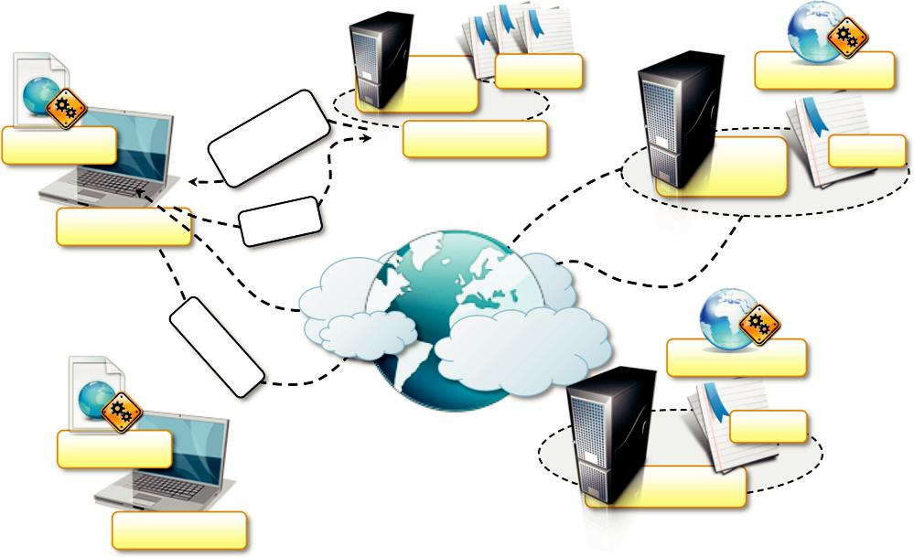

WS Client

Application

Response(WSDL)

Query

Web | WSDL(s) | Web Service
Server
UDDI Registry |  | WSDL
 | Web | WSDL
Server

Invocation

WS Client

Application

FIGURE 2.16

A Web services interaction reference scenario.

Web Service

WSDL

Application

exist for any mainstream programming language in the form of libraries or development support tools. This makes the use of Web services seamless and straightforward with respect to technolo-gies such as CORBA that require much more integration effort. Moreover, being interoperable, Web services constitute a better solution for SOA with respect to several distributed object frame-works, such as .NET Remoting, Java RMI, and DCOM/COM1 , which limit their applicability to a single platform or environment.

Besides the main function of enabling remote method invocation by using Web-based and inter-operable standards, Web services encompass several technologies that put together and facilitate the integration of heterogeneous applications and enable service-oriented computing. Figure 2.17 shows the Web service technologies stack that lists all the components of the conceptual framework describing and enabling the Web services abstraction. These technologies cover all the aspects that allow Web services to operate in a distributed environment, from the specific requirements for the networking to the discovery of services. The backbone of all these technologies is XML, which is also one of the causes of Web services’ popularity and ease of use. XML-based languages are used to manage the low-level interaction for Web service method calls (SOAP), for providing metadata about the services (WSDL), for discovery services (UDDI), and other core operations. In practice, the core components that enable Web services are SOAP and WSDL.

Simple Object Access Protocol (SOAP) [23], an XML-based language for exchanging structured information in a platform-independent manner, constitutes the protocol used for Web service method invocation. Within a distributed context leveraging the Internet, SOAP is considered an application layer protocol that leverages the transport level, most commonly HTTP, for IPC. SOAP structures the interaction in terms of messages that are XML documents mimicking the structure of a letter, with an envelope, a header, and a body. The envelope defines the boundaries of the SOAP message. The header is optional and contains relevant information on how to process the message. In addition, it contains information such as routing and delivery settings, authentication and authori-zation assertions, and transaction contexts. The body contains the actual message to be processed.

The main uses of SOAP messages are method invocation and result retrieval. Figure 2.18 shows an example of a SOAP message used to invoke a Web service method that retrieves the price of a
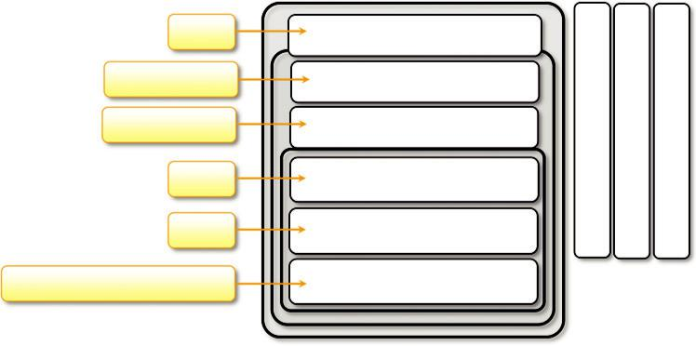

WSFL

Static → UDDI

Direct → UDDI

WSDL

SOAP

HTTP,FTP,e-mail, MQ, IIOP, ….

Web Service Flow

Service Discovery

Service Publication

Service Description

XML-based Messaging

Network

Security | Management | Quality of Service

FIGURE 2.17

A Web services technologies stack.

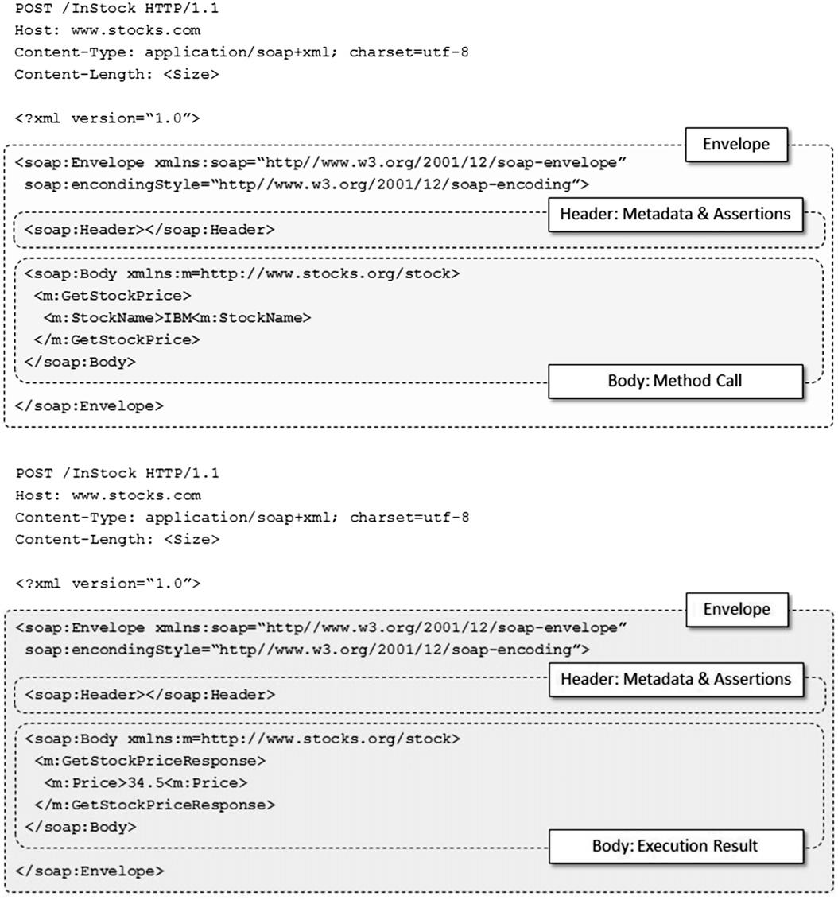

FIGURE 2.18

SOAP messages for Web service method invocation.

given stock and the corresponding reply. Despite the fact that XML documents are easy to produce and process in any platform or programming language, SOAP has often been considered quite inef-ficient because of the excessive use of markup that XML imposes for organizing the information into a well-formed document. Therefore, lightweight alternatives to the SOAP/XML pair have been proposed to support Web services. The most relevant alternative is Representational State Transfer

(REST), which provides a model for designing network-based software systems utilizing the client/ server model and leverages the facilities provided by HTTP for IPC without additional burden.

In a RESTful system, a client sends a request over HTTP using the standard HTTP methods (PUT, GET, POST, and DELETE), and the server issues a response that includes the representation of the resource. By relying on this minimal support, it is possible to provide whatever it needed to replace the basic and most important functionality provided by SOAP, which is method invocation. The GET, PUT, POST, and DELETE methods constitute a minimal set of operations for retrieving, adding, modifying, and deleting data. Together with an appropriate URI organization to identify resources, all the atomic operations required by a Web service are implemented. The content of data is still transmitted using XML as part of the HTTP content, but the additional markup required by SOAP is removed. For this reason, REST represents a lightweight alternative to SOAP, which works effectively in contexts where additional aspects beyond those manageable through HTTP are absent. One of them is security; RESTful Web services operate in an environment where no addi-tional security beyond the one supported by HTTP is required. This is not a great limitation, and RESTful Web services are quite popular and used to deliver functionalities at enterprise scale: Twitter, Yahoo! (search APIs, maps, photos, etc), Flickr, and Amazon.com all leverage REST.

Web Service Description Language (WSDL) [22] is an XML-based language for the description of Web services. It is used to define the interface of a Web service in terms of methods to be called and types and structures of the required parameters and return values. In Figure 2.18 we notice that the SOAP messages for invoking the GetStockPrice method and receiving the result do not have any information about the type and structure of the parameters and the return values. This informa-tion is stored within the WSDL document attached to the Web service. Therefore, Web service con-sumer applications already know which types of parameters are required and how to interpret results. As an XML-based language, WSDL allows for the automatic generation of Web service cli-ents that can be easily embedded into existing applications. Moreover, XML is a platform- and language-independent specification, so clients for web services can be generated for any language that is capable of interpreting XML data. This is a fundamental feature that enables Web service interoperability and one of the reasons that make such technology a solution of choice for SOA.

Besides those directly supporting Web services, other technologies that characterize Web 2.0

- provide and contribute to enrich and empower Web applications and then SOA-based systems. These fall under the names of Asynchronous JavaScript and XML (AJAX), JavaScript Standard Object Notation (JSON), and others. AJAX is a conceptual framework based on JavaScript and XML that enables asynchronous behavior in Web applications by leveraging the computing capa-bilities of modern Web browsers. This transforms simple Web pages in full-fledged applications, thus enriching the user experience. AJAX uses XML to exchange data with Web services and applications; an alternative to XML is JSON, which allows representing objects and collections of objects in a platform-independent manner. Often it is preferred to transmit data in a AJAX context because, compared to XML, it is a lighter notation and therefore allows transmitting the same amount of information in a more concise form.

Service orientation and cloud computing

Web services and Web 2.0-related technologies constitute a fundamental building block for cloud computing systems and applications. Web 2.0 applications are the front end of cloud computing systems, which deliver services either via Web service or provide a profitable interaction with

AJAX-based clients. Essentially, cloud computing fosters the vision of Everything as a Service (XaaS): infrastructure, platform, services, and applications. The entire IT computing stack—from infrastructure to applications—can be composed by relying on cloud computing services. Within this context, SOA is a winning approach because it encompasses design principles to structure, compose, and deploy software systems in terms of services. Therefore, a service orientation consti-tutes a natural approach to shaping cloud computing systems because it provides a means to flexi-bly compose and integrate additional capabilities into existing software systems. Cloud computing is also used to elastically scale and empower existing software applications on demand. Service ori-entation fosters interoperability and leverages platform-independent technologies by definition. Within this context, it constitutes a natural solution for solving integration issues and favoring cloud computing adoption.

